**Over All Customer Service ERP**

**“EnerSys Care”**

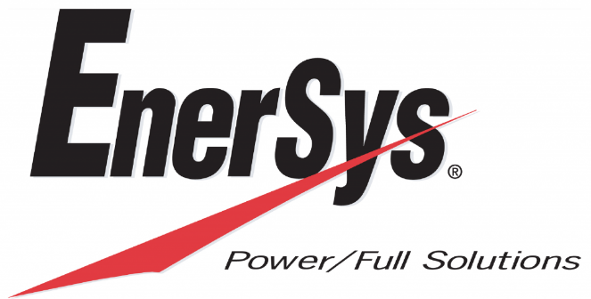

|  |  |
| --- | --- |
| Process | EnerSys Care ERP Portal |
| Process Briefed by | S. Mani Raj & Department Concerns |
| Documented by | S. Mani Raj |
| Version | V.1.0 |
| Date | 19th June 2018 |
| Signed off by |  |

# 1 Users and Roles

## Overview

EnerSys Care system has different users and roles associated with those users. Every user can

have only specific view and CRU rights depended on roles.

C-Create, R-Read, U-Update.

## 1.1 Different users in the system

1. Super Admin**.**
2. Admin-Service**.**
3. Admin-Expenses**.**
4. Employees**.**
5. Vendor / ESCA**.**
6. Customer**.**



### 1.1.1 Super Admin

1. Super Admin is created by System Admin at the backend. There is no provision to add

super admin through the web portal.

2. Super Admin has all the rights in the system, updations, creating admins. Deletion is not available.

3. Super Admin can perform all level approval operations.



Fig a: Super Admin -CRU operations * Indicates Static *Indicates Dynamic

### 1.1.2 Admin Service

1. Admin can perform CRU operations.

2. Admin can create new user and can assign roles using user administration section

3. Admin can perform all level approval operations.

Note: Admin can act as super admin when all the privileges are assigned



Fig b: Admin Service -CRU operations * Indicates Static *Indicates Dynamic

### 1.1.3 Admin-Expense

1. Admin can perform CRU operations related to only Expense Portal.

2. Admin can create new user and can assign roles.

3. Admin can perform all level approval operations.



Fig c: Admin Expense-CRU operations * Indicates Static *Indicates Dynamic

### 1.1.4 Employees

* Employees Login will work as per the privilege assigned.
* Service team Employees will have provision to upload the Manual FSR report from their login if failed to do e-FSR.
* Expenses / Advances can be book from their logins.
* Profile Information can be accessed.
* Service team Employees can access dashboard which consists of complaint status.

### 1.1.5 Vendor / ESCA

* Vendor will have 2 types of logins
  + - 1. Vendor Login : Here he can access all the complaints assigned to Vendor
      2. Employee Login: It’s Individual login for his Employees.
* Vendor can access dashboard which consists of complaint status assigned. Not all the dashboards blocks.
* Vendor Employee login will have provision to upload the Manual FSR report from their login if failed to do e-FSR.
* Vendor / Employee logins can view Complaints / TT Number allotted to him only.

### 1.1.6 Customer

* Customer can log complaints through the portal
* Customer can view only complaints lodged against his sites.
* Customer can view only his site details in Site master module.
* Customer can access dashboard which consists of complaint status assigned. Not all the dashboards blocks.

# 2 Registration

* + - No Registration is allowed for this ERP openly.
    - EnerSys Care is a closed system only Super Admin / Admin Service / Admin Expense can register the Users.

## 2.1 Registration Users

1. User Registration
2. Vendor /ESCA Registration
3. Customer Registration
4. Login

## 2.2 Detailed Requirements

### 2.2.1 User Registration

Fields required while registration User in **“Employee Master”** module**.**

* **Full Name**: Name of the User
* **Employee ID:** Registered in HR Records, Primary key for Users, which also used for

Login

* **Email ID:** For company roll employees Official Email ID & For Vendor roll employee it should be their official Email ID. When user forgot the password the reset link will be shared to given Email ID.
* **Mobile Number:** Contact number of the person. which also used as Password for first time login
* **Department:** Select the user department as per HR records.
* **Designation:** Select the user designation as per HR records.
* **Zone:** Which Zone user is working.
* **State:** Which State user is working.
* **Warehouse Code:** Selection will happen only if he is responsible for Inventory Management. It is not a Mandatory field.
* **Base Location:** Location of the users from where he is working for company / As per the records of HR department.
* **Qualification:** Educational Qualifications.
* **Specialization:** User Specialization in his Educational Qualification **/** inReal time.
* **Total Experience:** Overall Work experience before Joining in EnerSys India Batteries Private Limited.
* **Joining Date:** As per the HR department Records.
* **Employee Role:** Select the user roll based on the Department.
* **Privileges:** The key selection, based on this the user functionality and UI works.
* **Asset Type:** If the Employee is responsible of any company assets this selection will be done. This is not Mandatory field.
* **Asset Name:** Based on the Asset Type the asset name will display. This is not Mandatory field.

* **Asset Make:** Asset Make which was issued by company. This is not Mandatory field.
* **Asset Serial Number:** Asset serial number which was available on Asset. This is not Mandatory field.
* **Cash Card:** The input details related to Finance department, if company issued any cash card those details need to be entered.
* **Opening Balance:** The input details related to Finance department, if employee contains any opening balance as per the records those details need to be entered.
* **TS Person Notified:** This selection is related to Technical Service team, if user is related then select as “Show” if not related Select as “Hide”.

### 2.2.2 Vendor/ESCA Registration

Fields required while registration vendor.

* **Company Name**: Name of the Vendor company.

* **Vendor ID**: This ID will be given by EnerSys, Primary key for Vendors, which also used for Login
* **Zone:** Which Zone Vendor is looking after to provide the Services as per the Agreement / Rate contract done with EnerSys India Batteries Private Limited.
* **State**: Which Zone Vendor is looking after to provide the Services as per the Agreement / Rate contract done with EnerSys India Batteries Private Limited.
* **Address**: Detail address of the company.
* **Location**: User need to select the location of the company through

map and store location details.

* **Password**: Will be Created by Super Admin / Admin- Service.
* **Mobile**: Contact number of the person who is registering.
* **Email ID**: For further communications.

### 2.2.3 Customer Registration

Fields required while registration Customer.

* **Customer Name**: Name of the Customer as the Sale Details
* **Company Code:** The Shortest form given by EnerSys to the Customer Name, this code will reflect in Entire System where ever the requirement is there.
* **Customer ID**: This ID will be given by EnerSys, Primary key for Customer, which also used for Login.
* **Email**: For further communications.
* **Password:** Will be Created by Super Admin / Admin- Service.
* **Warranty from Dispatch(Months)**: Warranty agreed mutually as per the Purchase order.
* **Warranty from Installation(Months)**: Warranty agreed mutually as per the Purchase order.
* **Segment**: Business Category, select to which Segment Customer Belongs. This selection is very crucial as the e-FSR forms in Mobile app work with this.
* **Schedule:** If Customer is under AMC of us, then this selection will happen.
* **Product Code:** Select the list of Products which are sold to Customer.
* **Upload PO Copy:** Upload any one PO copy that stands on Warranty Terms Selected above. Please note System allows only PDF files.

## 2.3 Manual Verification (Registration)

* The Manual Verification belongs to only Vendor/ ESCA.

* Before Super Admin / Admin-Service create a user registration, there is a manual verification process, it is completely offline (out of the system).
* Without an Agreement / Work order the Registration will not done for Vendor/ ESCA.

# 3 Detailed Flow diagram of EnerSys Care Web Portal







Fig d: Functional Flow chart of Web Operations

* The Entire Above Functional Flow chart covers below mentioned.
  + - 1. Complaints Handling

&

* + - 1. Material Management

# 4 Mobile Application Flow Diagrams

This cover the complete Mobile Application Registration, Installation and Working functionality process.

## 4.1 Mobile APP Installation & Registration Process



Fig e: Mobile APP Installation & Registration Process

## 4.2 Mobile Application Functional Flow



Fig f: Mobile APP Functional Flow

# 5 Modules

This covers number of Modules present in Application and their functionalities in details

## 5.1 Dashboard

It’s a graphical representation which can be filtered with various functions by which Graphs will be updated accordingly.

### 5.1.1 Ticket Status

Description: This is a Table view which shows all the Tickets present in various Levels.

Data Source: Tickets Modules –> Levels.

Filters: State, Customer, Segment, Activity, Faulty code, Aging, Year.

Calculation: Counts the Number of Tickets logged and Display in Table view as per the Level.

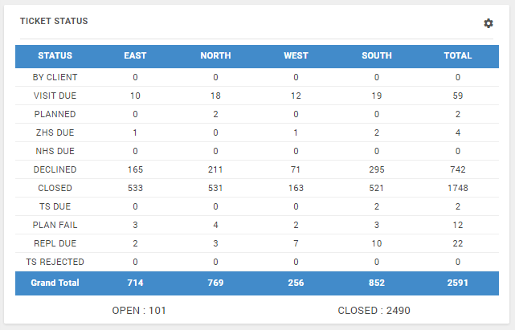

Fig g: Tickets Status Table View

### 5.1.2 Customer Pulse

Description: This is a Speedometer Graph view which shows customer pulse by capturing the given rating by customer in e-FSR

Data Source: e-FSR –> Customer Review

Filters: State, Customer, Segment, Activity, Year.

Calculation: Calculates Average against the 5 Points where customer provided his rating and will display in graphical view in percentage.

Example:

|  |  |  |  |  |  |  |  |  |
| --- | --- | --- | --- | --- | --- | --- | --- | --- |
| **Description** | **Rating 1** | **Rating 2** | **Rating 3** | **Rating 4** | **Rating 5** | **Total Target** | **Total Achieved** | **Percentage** |
| e-FSR -1 | 3 | 3 | 5 | 5 | 5 | 25 | 21 | 84% |
| e-FSR -2 | 4 | 4 | 5 | 3 | 3 | 25 | 19 | 76% |
| **Average Percentage** | | | | | | | | **80%** |

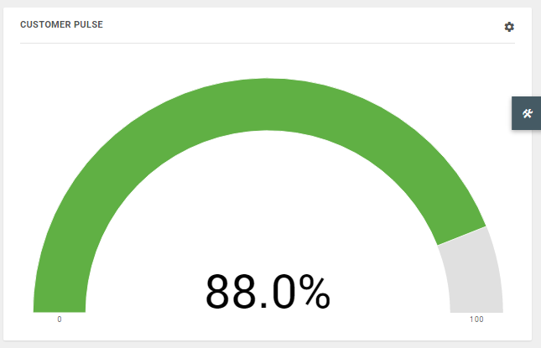

Fig h: Customer Pulse Speedometer Graph View

### 5.1.3 Today Info Report Block

Description: This is Bar Graph which shows activities planned today at various levels

Data Source: Tickets Modules –> Levels.

Filters: State, Customer, Segment, Activity, Faulty code, Aging.

Calculation: Counts the Number of Tickets Action taken on today’s date at various levels and Display in graphical view.

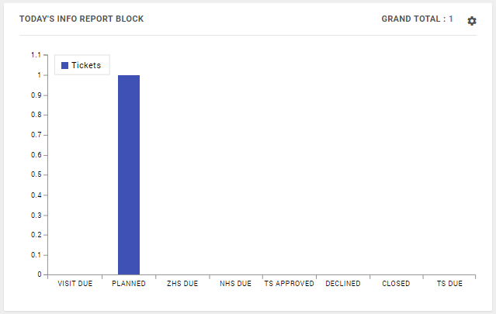

Fig i: Todays Info Report Bar Graph View

### 5.1.4 TAT (Turn Around time)

Description: This is Pie Graph which shows percentage of Tickets closed at different TAT Levels.

* TAT -1 : 1 – 15 Days
* TAT -2 : 16 – 25 Days
* TAT -3 : More than 25 Days

Data Source: Tickets Modules –> Export –>TAT

Filters: State, Customer, Segment, Activity, Faulty code, Year.

Calculation: It takes the percentage of each TAT Level with total Tickets.

1. For single visit Ticket its calculates between closing date minus Complaint Logged date
2. For Multiple Visit, it calculates between closing date of last visit minus Complaint logged date.

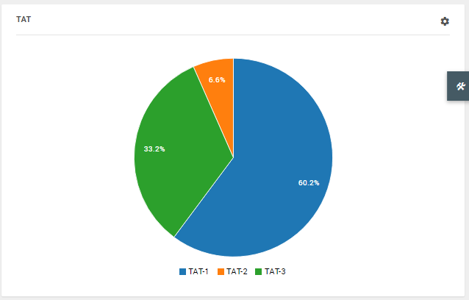

Fig j: TAT Pie Graph View

### 5.1.5 Monthly Analysis

Description: This is Bar Graph which shows month wise total Tickets Logged Vs Tickets Closed / Declined.

Data Source: Tickets Modules –> Levels.

Filters: State, Customer, Segment, Activity, Year.

Calculation: Counts the Number of Tickets logged Vs Tickets Closed / Declined on every Month.

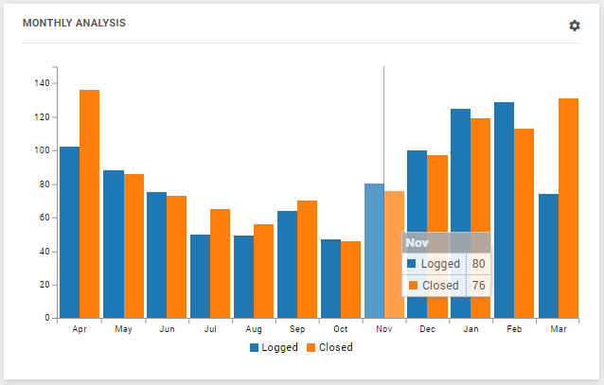

Fig h: Monthly Analysis Bar Graph View

### 5.1.6 Nature of Activity

Description: This is Doughnut Graph which shows the percentage against Nature of Activity of all Tickets Logged.

1. WS: Warranty Support
2. OT: Others
3. I&C: Installation and Commissioning
4. AT: Acceptance Test

Data Source: Tickets Modules –> Nature of Activity.

Filters: State, Customer, Segment, Year.

Calculation: It takes the percentage against Nature of Activity of all Tickets logged.

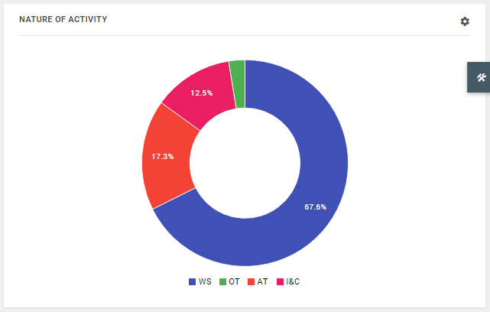

Fig i: Nature of Activity Doughnut Graph View

### 5.1.7 Fault Analysis

Description: This is Doughnut Graph which shows the percentage against Fault code selected at the time of e-FSR submission.

Data Source: Tickets Modules –> e-FSR –> Service Engineer Observation –> Fault Code.

Filters: State, Customer, Segment, Activity, Year.

Calculation: It takes the percentage against Fault code of all e-FSR generated.

Note: Graph Doesn’t calculates the Fault Code’s “Installation & Commissioning “ , Acceptance Test.

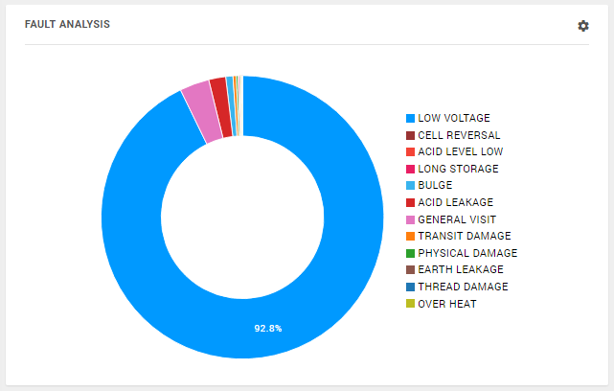

Fig j: Fault Analysis Doughnut Graph View

### 5.1.8 Product Contribution in Failure

Description: This is Pie Graph which shows the percentage of Product wise failure by collecting the data from faulty cells selected from e-FSR.

Data Source:

1. Fault Count: Tickets Modules –> e-FSR –> Service Engineer Observation –> Fault Cells.
2. Product: TT Number –> Product Code

Filters: State, Customer, Segment, Activity, Fault Code, Year.

Calculation: It takes the percentage against Product wise based on the Fault cell count.

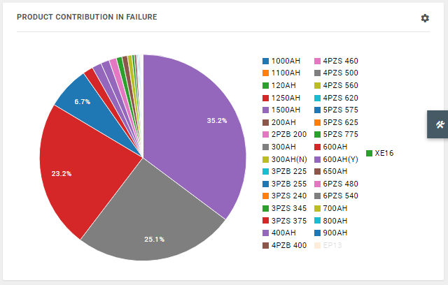

Fig k: Product contribution in Failure Pie Graph View

### 5.1.9 Manufacture Month Wise Failure

Description: This is Combo Graph which shows the percentage of Product wise failure against Month Wise Manufactured by collecting the data from faulty cells selected from e-FSR.

Data Source:

1. Fault Count: Tickets Modules –> e-FSR –> Service Engineer Observation –> Fault Cells.
2. Product: Tickets Modules –> TT Number –> Product Code
3. Manufactured Month: Tickets Module –> e-FSR –> Service Engineer Observation –> Battery Observation –> Cell serial Number.

Filters: State, Customer, Segment, Activity, Fault Code, Year.

Calculation: It takes the count of faulty cells against Product wise and Month Wise Manufacture.

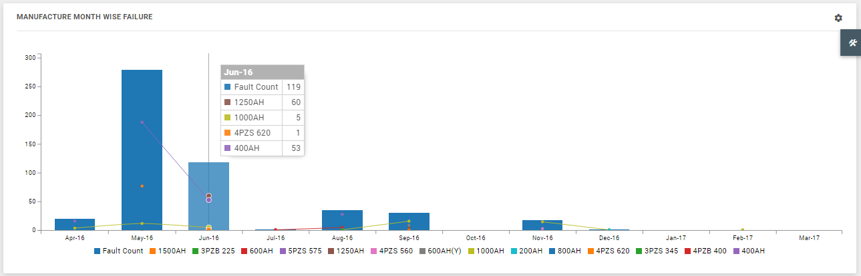

Fig L: Manufacture Month wise failure Combo Graph View

Export and Display Mechanism:

1. In export, all the details including each visit of Ticket wise faulty cell serial number selected by service engineer in e-FSR will show.
2. Display count in graph will avoid the duplicate cell count and show only unique count.

## 5.2 Planner

This module is all about assigning the schedule Vs Activity executed for Service Department users. From which it displays a summary of Total Man days, Engaged and Vacant as shown below.

The View of planner can be shown in three ways i.e., 1. Month 2. Week 3. Day

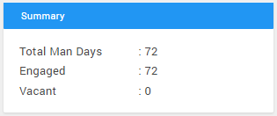

### 5.2.1 Assigning Schedule

Description: To assign a schedule / Event to user click Assign Schedule button and fill the details which are available and submit the request. (Fig M: Assign new schedule to user)

On the right site of inside planner Module, we can view the list of events assigned to users with details. (Fig N: List view & View details)

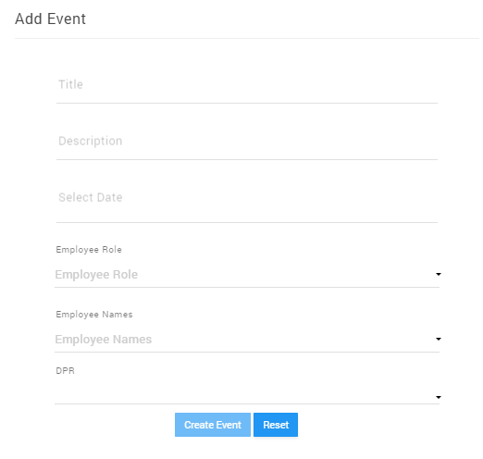

Fig M: Assign new schedule to user

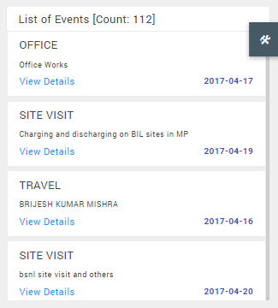 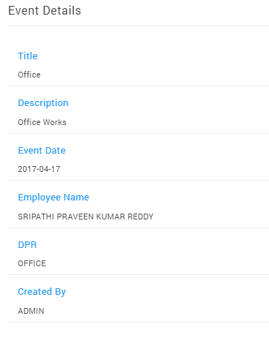

Fig N: List view (Left Side) & View details (Right Side)

Data Source: Assign Schedule can be done in two ways

1. By accessing Assign Schedule button and providing the details accordingly
2. From ticket module, when any ticket is planned to user on particular date, planner modules picks the TT Number and will show in planner module against the user on specific date.

### 5.2.2 DPR View

Description: The data input given by user in Mobile APP on specific date will link to Planner Module.

Data Source: Mobile Application –> DPR

### 5.2.3 Color code Identification

Description: There is a color identification between DPR View, Event Planned and TT Number Assigned

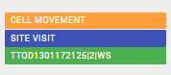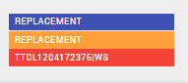

Orange Color: Event Planned

Blue Color: DPR Submitted

Green Color: TT Number Assigned

Red Color: Plan Failed TT Number

### 5.2.4 Email Calendar

Description: There is a dedicated button on the left side “Email Calendar” on click of button a pop up with below described options will show, after selecting the fields click on “Send Calendar” button by which EnerSys Care system will trigger a mail based on the field selections criteria.

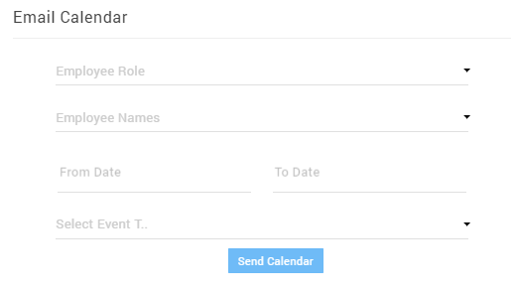

Fig O: Email Calendar

* EMP Role: Select the employee role consists of 3 roles in the System a) On roll b) On roll Engineers c) ESCA roll Engineers.
* Employee Name: The list of employees shown in drop is related to EMP role selected above, here we can select multiple employee name.
* From Date and To date: Select the duration of calendar which need to mail the user through system.
* Event Title: Planner Modules deals three events, here we can select multiple events.

a) Tickets: Planned Tickets

b) DPR: Submitted DPR

c) Event: Assigned Event

Email Template:



### 5.2.5 Communication System

Description: Planner communication to users will be done by below two gateway methods

1. SMS: Whenever any schedule / Event is planned against Employee a SMS will generate to user

Example: “Dear Team, Activity CELL MOVEMENT is Assigned to you on dated 2017-03-30 09:36:51, Execute the same, for more details go through the email.”

1. Email: Every week Saturday email will be triggered to user at 7:00 AM of Monday to Friday.

### 5.2.6 Filtering

Description: The below image shows the detail filtering options which can be used to filter the Calendar display.

Backward of Range Selected Month / Week / Day

All the three i.e., Month / Week / Day act as Range filters to Calendar

Frontward of Range Selected Month / Week / Day

Filters Calendar to today’s Date



Fig P: Planner Filtering

All the above root was in Employee master, filter will happen accordingly based on the which Zone/State/Role to Employee

## 5.3 Spot Tickets

Description: Spot Means Dummy / Temporary TT number, this module shows Tickets Generated by Service Engineers through Mobile Application. And later Call center team will generate the Live TT Number.

Spot Tickets are sub divided in to 2 types of tickets one is “SPOT” and second one is “OFFLINE” the details explanation of these are mentioned below.

Data Source: Mobile Application -> Tickets Tab -> Float Button -> Segments

### 5.3.1 Table View Details

Level Name Tells Spot / Offline

Offline / Spot Ticket Number

e-FSR submitted Date

e-FSR submitted Date

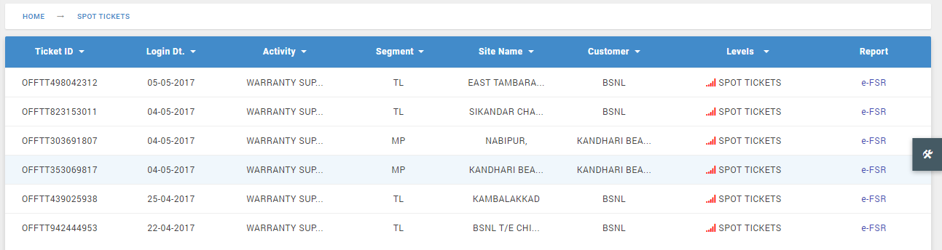

Note: 1. On click of each heading, will act as search

2. On click of Ticket Number pop up will show for Spot / Offline TT to Live TT Number generation

### 5.3.2 Spot

Description: When Service Engineer selected TT Number not available while filling the e-FSR accessed from float button, then generated TT Number is called “SPOT”.

“SPOT TT can be to convert to Live TT Number by creating a New site in site master or by selecting existing site in Site master– But cannot link to existing TT Number”.

Data Source: Mobile Application -> Tickets Tab -> Float Button -> Segments ->-> TT Availability -> N0

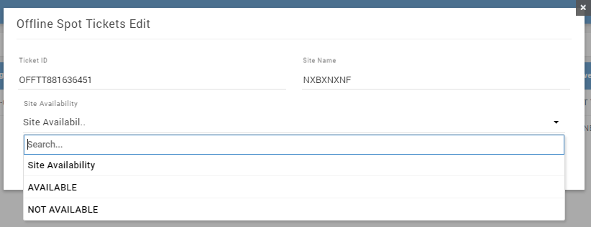

Fig Q: Spot Ticket Site Availability Selection

### 5.3.3 Offline

Description: When Service Engineer selected TT Number available while filling the e-FSR accessed from float button, then generated TT Number is called “OFFLINE”.

“OFFLINE TT can link with Live TT Number, list of Live TT’s will be shown based on “Level- Planned” and “Segment” i.e., Offline TT Generated by Service Engineer.

Data Source: Mobile Application -> Tickets Tab -> Float Button -> Segments -> TT Availability -> Yes

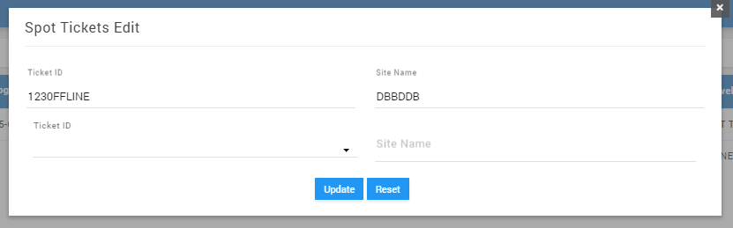

Fig R: Offline Ticket showing Live TT Selection

## 5.4 Tickets

Description: This module handles all the Complaints / TT Numbers logged and track the status under various levels.

### 5.4.1 Table view details

Material Status against each TT number

Live TT Number includes combination of State & TT Logged date

Latest e-FSR report

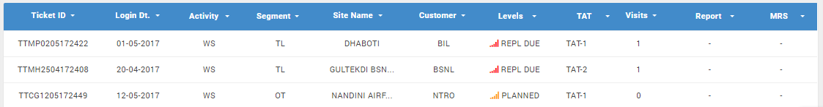

Note: 1. On click of each heading, will act as search box

2. On click of Ticket Number a navigation panel from right side will show with TT details and edit / print/download etc., options

### 5.4.2 New TT Registration

Description: To generate a new TT number click on bottom right Float button, which will populate a registration form by filling all the details and submitting unique TT Number will be generated.

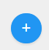

Fig S: Float button- To access New TT registration form

Key Points: TT Number generated will be under two formats

For the first-time TT Number registered against the site / if the site TT registered is of out of warranty system will give Unique TT Number.

Example: TTCG1602161260

2. If the same Site registered more than one complaints under warranty then the TT number will be generated in a sequence of first TT number with Alphabet continuation.

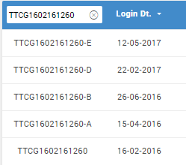

**Registration form:**

Major Field details to keep in mind while while registration New TT Number in **“Tickets”** module**.**

* **Nature of Activity**: Data source for the drop down is “Admin -> Settings -Activity”, There are three fields in this drop down

1. Acceptance Test: On selection of this, new fields will be added in registration form 1. PO Number 2. PO Date 3. Upload Po Copy.
2. Installation & Commissioning: On selection of this, new fields will be added in registration form 1. PO Number 2. PO Date 3. Upload Po Copy
3. Warranty Support: No Addition fields changes will happen in form.
4. Others: Complaint registered by selecting this nature of activity will take segment also as OTHERS, and site ID will become input box, instead of collecting the data source from site Master.

This Activity should be selected only when there is a complaint with No Site conditions, because e-FSR will show only fields BTR, Service Engineer Observations and Customer Comments.

The below are the fields need to provide for registering the complaints, the form fields will dynamically change based on the user selection of “**Nature of Activity”**

Please note: The Create Ticket Form will fetch the Site details from “Site Master Module” by providing site ID in Tickets Module, No manual input of any field data is allowed here apart from remarks.

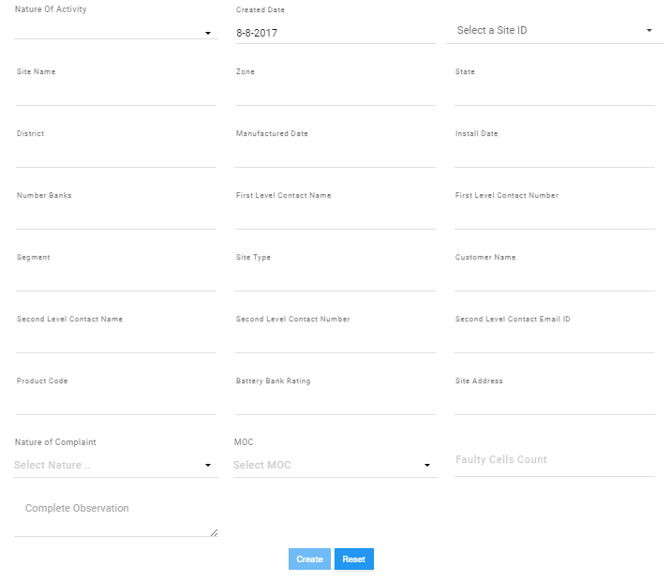

Input given will display the results in drop down by fetching the details from Site ID of Site Master module

**Out of Warranty Remarks:**

When user given / Selected the site ID in Create TT form, the system will check for warranty status of the site, if the site falls under out of warranty the below message will be prompt from system (as shown in below picture), then user need to enter the out of warranty remarks to generate TT Number.

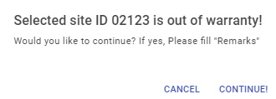

### 5.4.3 Levels

Description: Level names are defined to know the Exact status of TT number, Various Levels define the state of TT Number and Action need to be taken, there are total ‘11’ Level names in Tickets Module (Note: These Level Names are static).

1. **BY CLIENT**: Tickets logged through customer login and waiting for call center team to clear.
2. **VISIT DUE**: New Ticket logged by call center will team will show under Visit Due which will allow to Plan the Ticket.
3. **PLANNED**: When Visit due ticket is planned then TT Number will be under Planned Level.
4. **PLAN FAIL:** If e-FSR is not linked to the Planned ticket on Planned date, then TT will show under Plan fail Level.
5. **ZHS DUE**: e-FSR generated against planned Ticket will first come to ZHS due level for verification.
6. **NHS DUE**: After ZHS verification if required ZHS user can send Ticket to NHS Level
7. **TS DUE**: Any material requirement suggested by NHS the TT Number will show in TS Due level.
8. **TS REJECTED**: Tickets Rejected by TS user will show in TS Rejected Level
9. **REPL DUE**: After TS Approval, the Ticket Level will show under REPL DUE, which will again allow user to plan Ticket.
10. **CLOSED**: Tickets closed by ZHS / NHS will show in Closed Level.
11. **DECLINED**: Tickets declined by ZHS / NHS / Call center Team will show in Decline Level.

### 5.4.4 Export

Description: Ticket Module Export provides detail information of data reports of mostly covered input fields, the reports are sub divided in to 4 Data types.

**TICKETS**: Exported file shows Tickets logged details with Minimal details

**TT SA:** Exported file shows complete data including data given in e-FSR

**TT BTR:** Exported file shows Faulty cell serial number with Manf. date

**TS CAR:** Exported file shows TS approved Tickets data with CAR (Corrective Action Report Number).

### 5.4.5 Communication System

Description: Tickets Module use 2 types of communication system

1. **SMS Services:** Third Party application “Bhashsms.com” API was used to send the SMS from EnerSys Care Application.
2. **Email Services:** “PHP Mailer” with Office 365 email account / Gmail account was used to communicate the emails from System.

The below are the list of SMS system and Email Systems communications at various Levels to various users.

**SMS communication to Users:**



**Email communication to Users:**



## 5.5 Site Master

Description: This module handles all the Site details of customer logged complaints and can also import the sale data of batteries installed at customer place.

### 5.5.1 Table view details

Warranty Status which is Auto calculated

Site ID, which should be unique

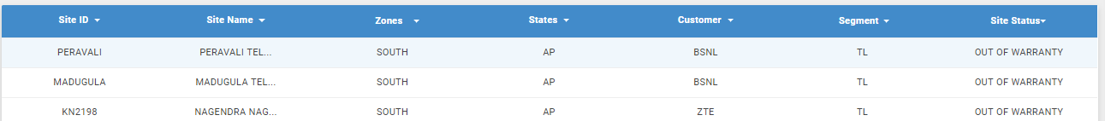

### 5.5.2 New Site Registration

Description: To generate a new Site click on bottom right Float button, which will populate a registration form by filling all the details and submitting site details will store in Site Master.



Fig T: Float button- To access New TT registration form

Key Points:

1. No Duplicate site ID’s can store.
2. Warranty calculation is based on Manufacture date and Sale invoice number

**Registration form:**

The below are the fields need to provide for registering the site, the form fields.

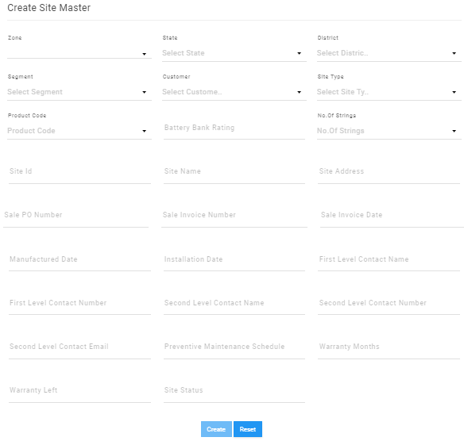

### 5.5.3 Warranty Calculation

Description: Against each site warranty calculation will happen, which says if the site falls in “warranty” or “Out of warranty”

Calculation: Sale Invoice Date minus (-) Installation Date in New Site creation form, the result which arrived will validate against the Customer wise warranty, customer wise warranty wise given at the time of new customer creations



For declaring the warranty status like warranty” or “Out of warranty system will always picks which will comes first as “out of warranty”.

### 5.5.4 Export & Import

Export: Site Master Module Export provides detail information of Site records.

Import: All the site details need to be filled in predefined format available and can import the excel file to store bulk records of site records.

## 5.6 Employee Master

Description: This module handles all the Employee Information where we can add employee and can deactivate an employee.

### 5.6.1 Table view details

EMP ID, which should be unique

Employee Working Status

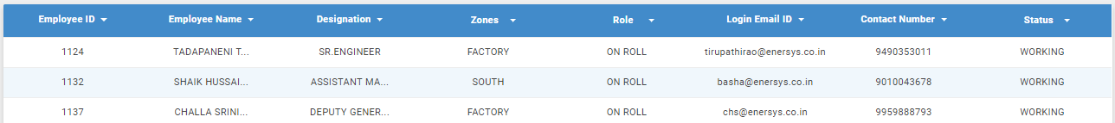

### 5.6.2 New Employee Registration

Description: To add new Employee click on bottom right Float button, which will populate a registration form by filling all the details and submitting Employee details will store in Employee Master.



Fig T: Float button- To access New TT registration form

Key Points:

1. No Duplicate Employee ID’s can store.
2. The display of user login is based on the Zone, States, customer, warehouse fields selected.

### 5.6.3 Employee Deactivation

Description: To deactivate the Employee click on Edit button against employee and give Resignation date input and submit, now the status of employee will change to ‘Resigned’ ( By which user can still login to his login), and again click on Edit button and in the upload file option upload NOC certificate, now status of employee will change to ‘Relieved’( Now user account is locked and he cannot login to the portal.)

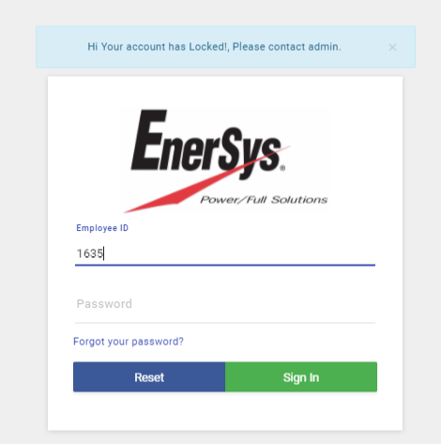

### 5.6.4 Export

Description: Employee Master Module Export provides detail information of Employee information.

## 5.7 Expense Tracker

Description: Expense Management portal is introduced with an object of managing the Employee advances and Expenses in an effective manner and to have a better control environment on employee advances.

### 5.7.1 Dashboard

Description: Dashboard shows a basic detail and approved limit of advance as shown in below image.

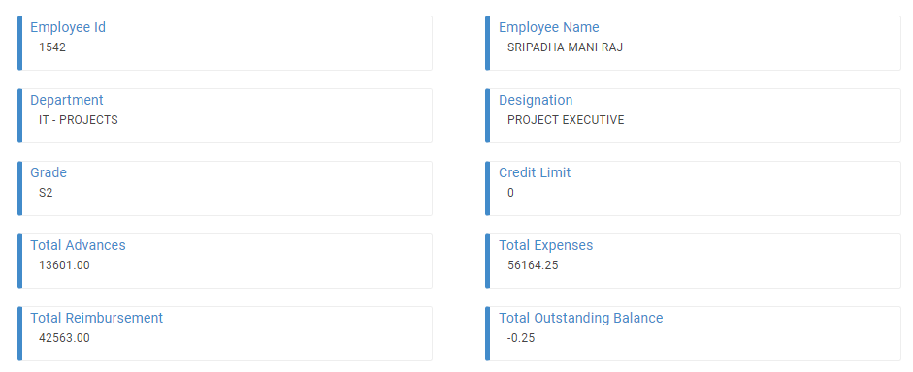

### 5.7.2 Creation of Advance Request

Description: To create a new advance request please click on ‘Advances’ sub menu and then you can find Float button on bottom right, click on that which will populate advance request form. Fill all the details and click on ‘Request Advance’ button to submit the request. Now system will trigger a mail to Approver or HOD.

Advance request Form:

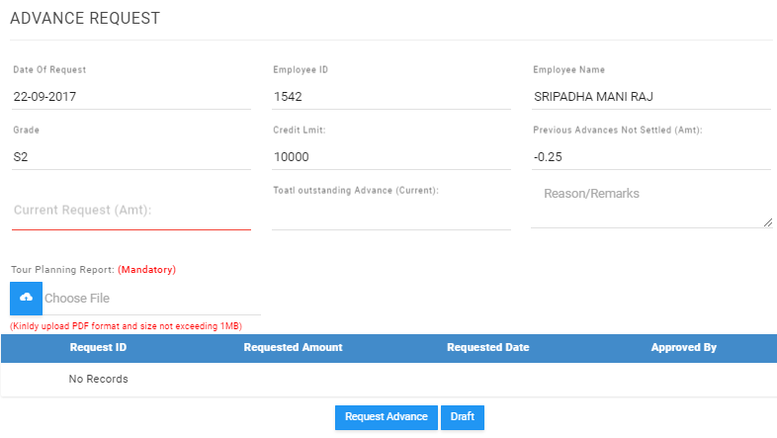

### 5.7.3 Modification of Advance request

When the outstanding advance including current request exceeds the approved limit expense portal prompts the message as shown below. Approval Limit exceeding message:

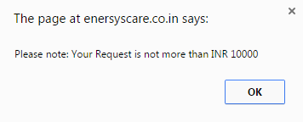

**Approve/Reject Advance:** Approver can approve or reject the advance and can update the comments accordingly as per the below given screen:

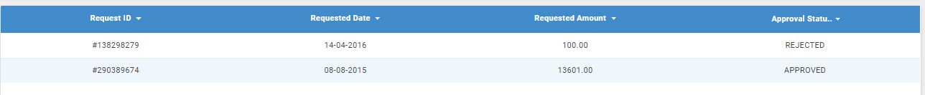

### 5.7.4 Advance Request Flow chart

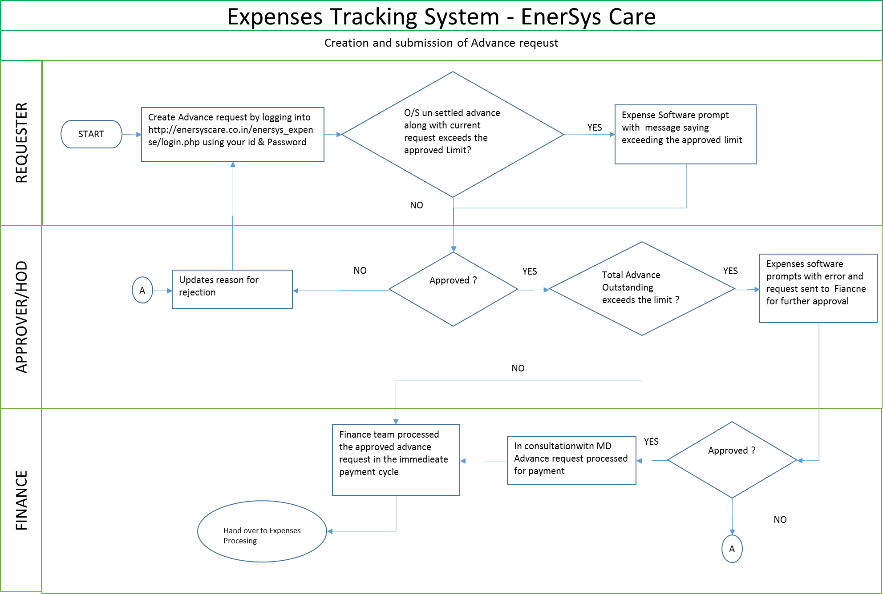

### 5.7.5 Creation of Expense request

Description: To create a new advance request please click on ‘Expenses’ sub menu and then you can find Float button on bottom right, click on that which will populate Expense request form. Fill all the details and click on ‘Submit Expense’ button to submit the request. Now system will trigger a mail to Approver or HOD.

Key Points:

* For Service Department Engineers the Expenses against fields, Lodging, Boarding, Local conveyances, and secondary transportations are fixed which are controlled at Admin panel under ‘[ALLOWANCES DETAILS](https://enersyscare.co.in/) -> SERVICES’.
* For other Department Employee Expenses against fields, Lodging, Boarding are controlled at Admin panel under ‘[ALLOWANCES DETAILS](https://enersyscare.co.in/) -> OTHERS’.

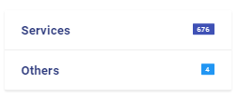

Expense request Form:

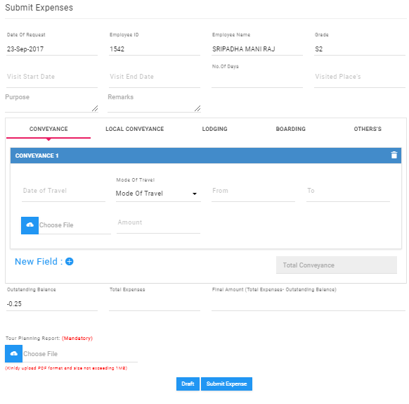

User hast to fill the details and must upload the Tour Report Soft copy (PDF format) using Choose File option as shown in the above screen shot.

Once the Request is submitted to HOD user cannot change the Request unless HOD rejects the request. However, user can save the expense sheet in drafts for his verification before submission for approval.

### 5.7.6 Expense Request Flow chart

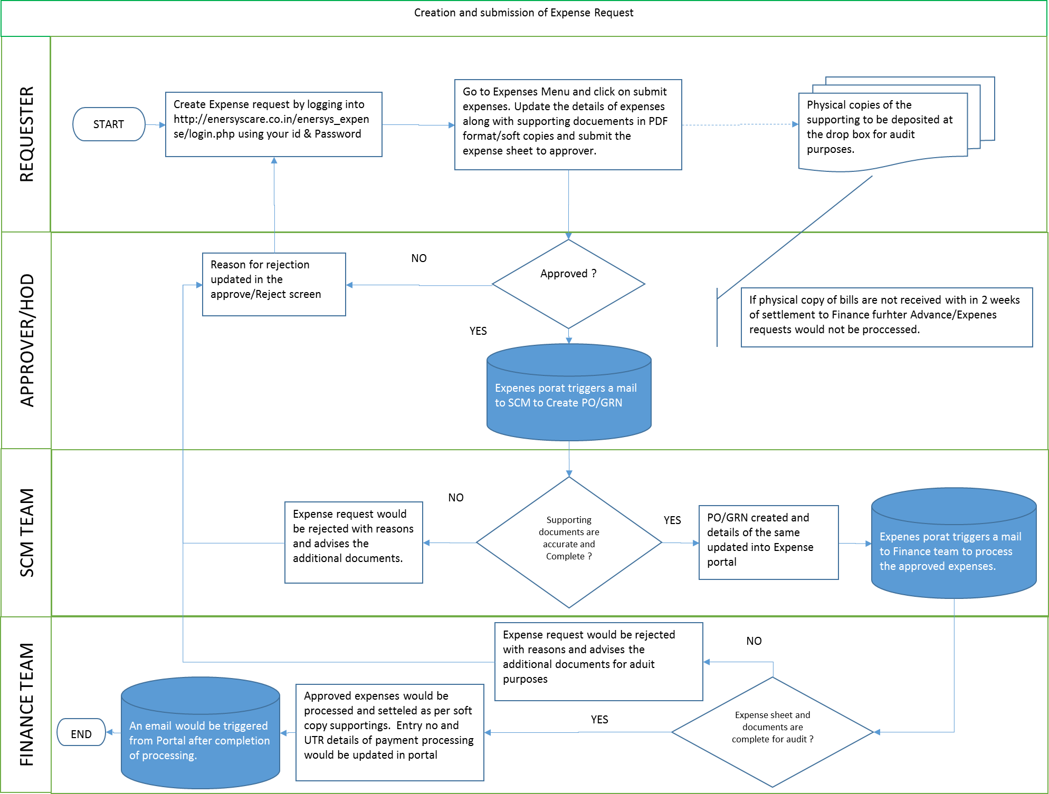

### 5.7. 7 Approval/Rejection By HOD

HOD or Approver should go to detailed view and click on edit button to view the request for approving. Approver can also view the supporting documents. In case HOD wants to reject the request, he should click on Reject button as shown in the below screen shot.

HOD/Approver must provide the reason for rejecting the request under Reasons/Remarks tab as shown in the below screen shot.

Approver / HOD Table View:

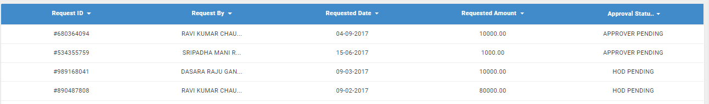

Approver / HOD action against Request View Advance:

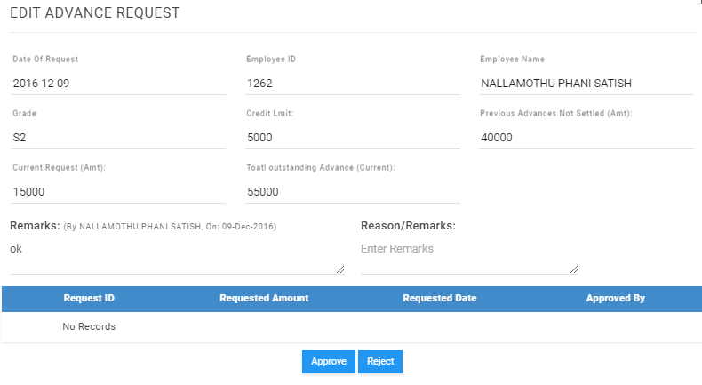

Once the Request gets approved SCM should verify the supporting and creates PO/GRN and updates the same details in Portal. SCM should go to detailed view and click on edit button to verify the supporting.

Post verification of supporting SCM create PO/GRN in FS and update the PO/GRN number as shown below. *This is a mandatory filed without this information SCM team cannot approve the request*

SCM action against Request Expenses:

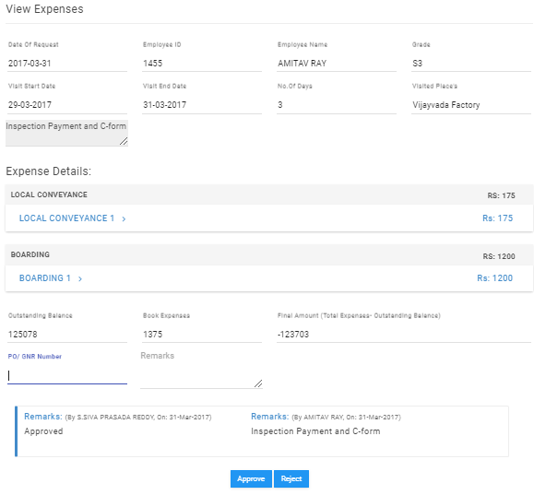

Verification and Settlement by Finance:

Finance executive verify the supporting by clicking on Edit button to ensure the details are adequate for audit.

Once the PO GRN number is in match and the supporting documents are complete, Finance executive push the Approved button. Once it is approved Finance will settle the expenses accordingly in Tally/FS.

.

### 5.7. 8 Export

List of reports that can are available in the Expense Module:

1. List of expense claims filed.
2. List of Advances request raised.
3. YTD advance summary report (for HODs/Approvers) person/department wise
4. YTD Expense summary report (For HODs/Approvers) person wise/department wise

### 5.7. 8 Expense Admin Flow chart

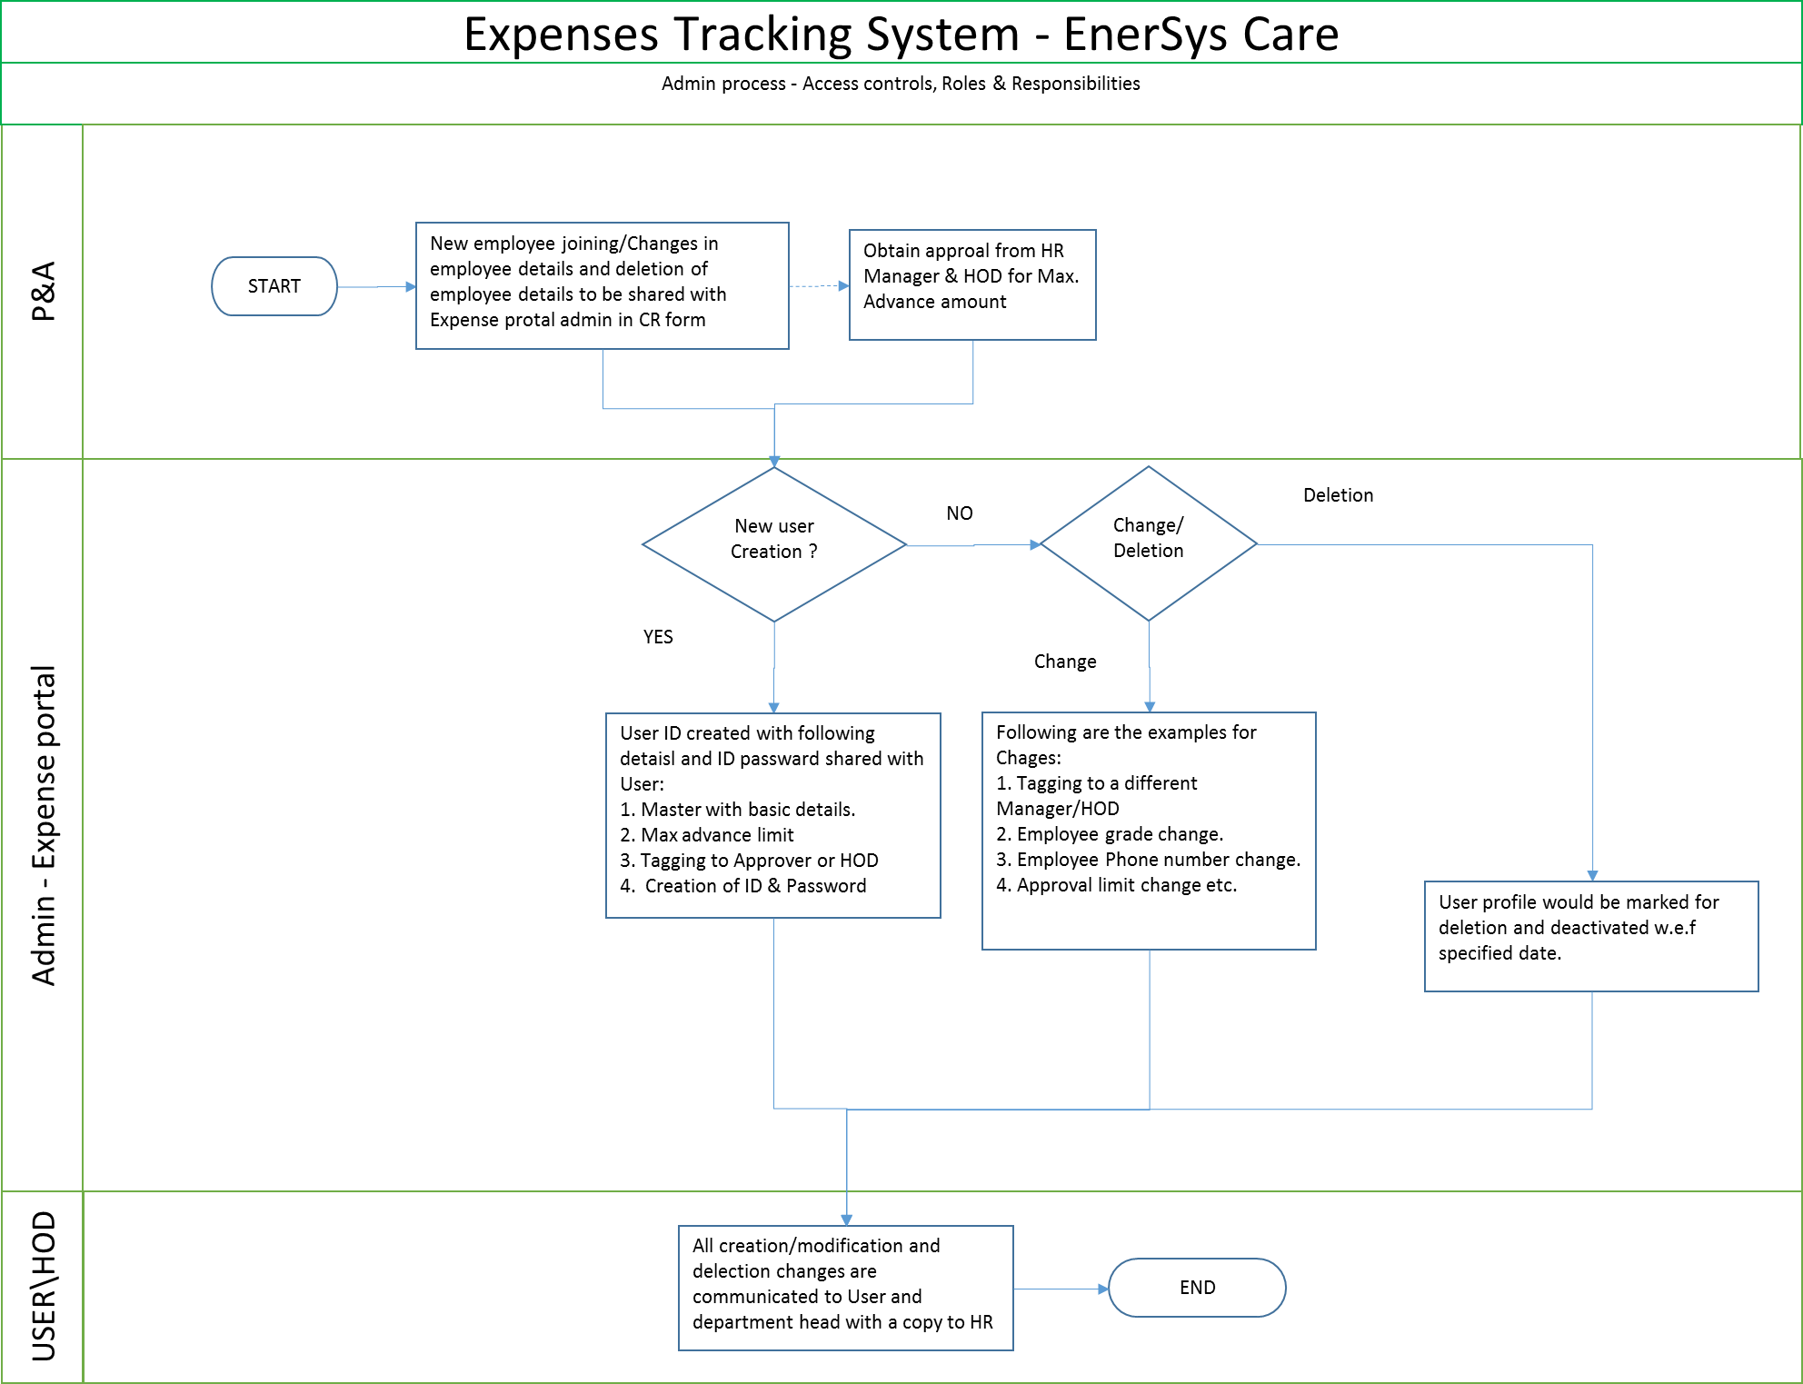

## 5.8 Filed Asset Management

Description: Filed Asset Management module is introduced with an object of tracking warranty cells send out from factory till faulty cells returned to factory with detail history of each cell movement to have a better control on inventory.

### 5.8.1 Balance Over View

Description: This page shows details stock information of assigned warehouses (Circle names) product wise and can be filtered with Warehouse, Customer, Item and Zone.

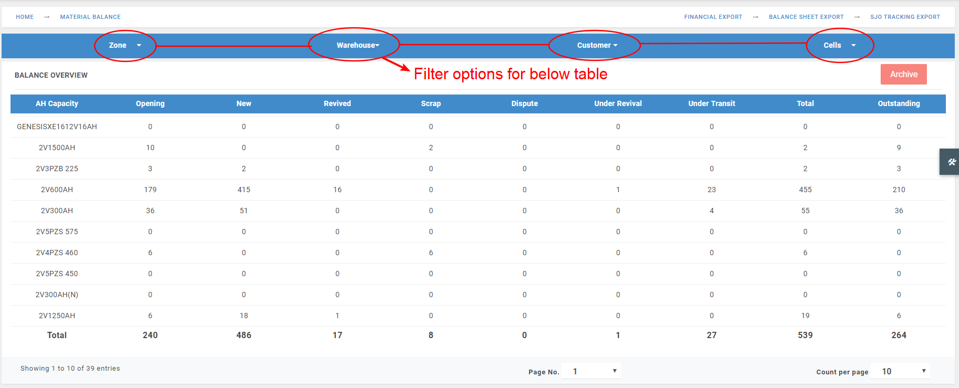

Key Points:

1. The *Opening Balance* valuesare generated after we performed *“Archive”* option (Refer above screen shot) at the end of Each financial year.
2. The *Outstanding* values are generated by calculating *Total New Cells Dispatched from Factory* minus *Total Faulty Cells Received at Factory.*
3. We need to use page nation by changing the below *Count per page* option at the bottom of the table to fetch all the records for Total Outstanding Balance.
4. The table view varies as per the warehouses allotted in Employee Master.

### 5.8.2 Inward Balance

Description: This page shows detailed Inward transactions information of assigned warehouses (Circle names) product wise and can be filtered with From Date, To Date, Warehouse & Item. The calculation is happening based on the inward transactions as shown below.

1. From Factory: New cells
2. From filed: New / Revived / Scrap Cells
3. From Branch: New / Revived / Scrap Cells to Factory

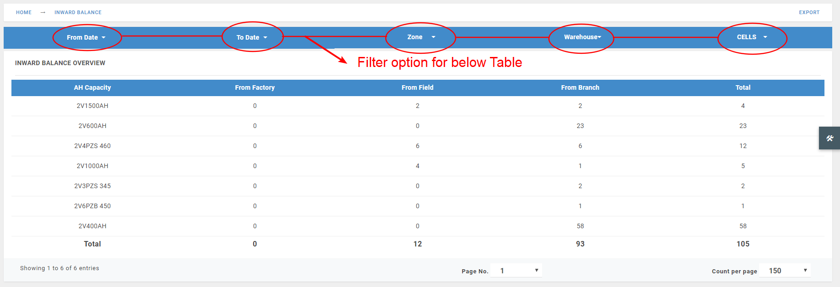

### 5.8.3 Outward Balance

Description: This page shows detailed outward transactions information of assigned warehouses (Circle names) product wise and can be filtered with From Date, To Date, Warehouse & Item. The calculation is happening based on the outward transactions as shown below.

1. New to filed: New cells Outward to Buffer Stock / TT Number
2. New to Branch: New / Revived / Scrap Cells
3. Revived to Field: Revived cells Outward to Buffer Stock / TT Number
4. Revived to Branch: Revived cells Outward to Factory
5. Scrap to Factory: Scrap cells Outward to Factory

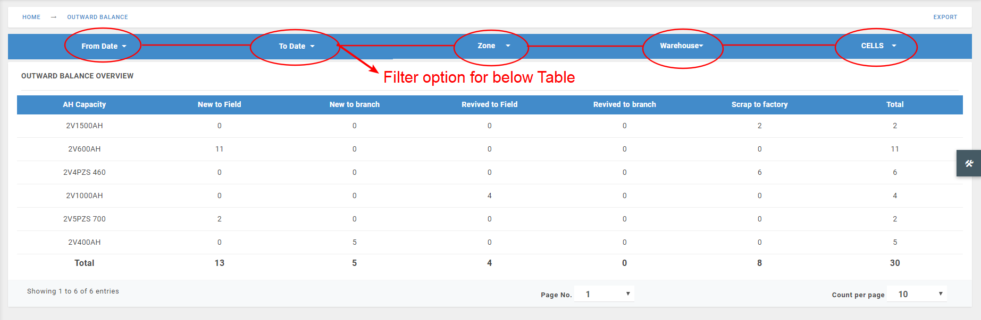

### 5.8.4 Material Inward

* **Material Inward at Filed Side:**

Description: To create a new transaction, click on bottom right Float button, which will populate a form by filling all the details and submitting reference number will be generated. This page allows to create new material inward transactions in below 3 cases.



1. **MRF**: First select the Warehouse against which the material inward need to be created, then select “MRF” from drop down menu list, by which MRF Numbers (with Material Request Status “Under Transit”) will be reflecting in next Drop down, now fill rest of the form details and click on submit.

Only *MRF* conditionoutwarded new cells from factory can be inward at Warehouse.

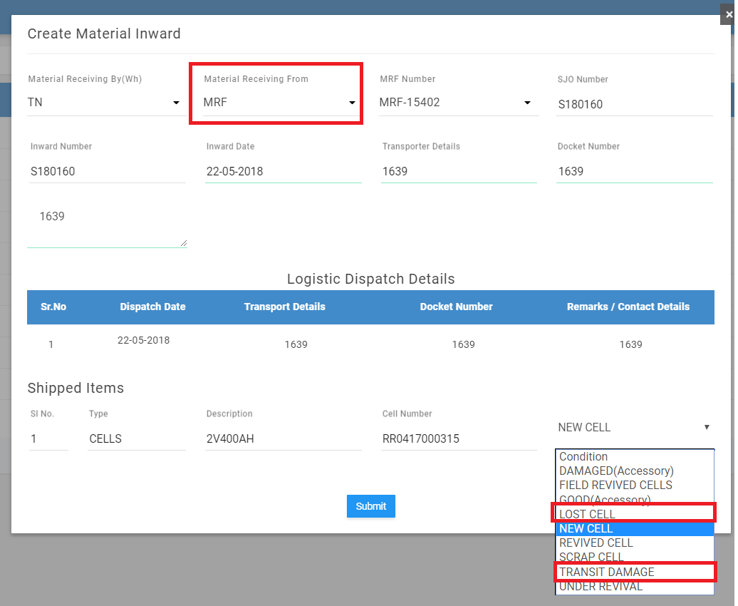

Here the Received items condition can be modified to Lost (as Dispute) / Transit Damage (as Scrap)at the time of Material Inward.

1. **Site**: 5 different cell conditions can be inward at warehouse with mapping of SJO / without mapping of SJO (NON SJO) and Customer buffer stock.

If the cells are mapped with SJO and closed inward transaction then if we select the SJO Number in Material Outward module the same cells which was inward will reflect. The same case with NON SJO also.

*Note: Mapping with SJO is the key for Material Balance statement which will track how many cells received against SJO how many send back against the SJO and what is the balance.*

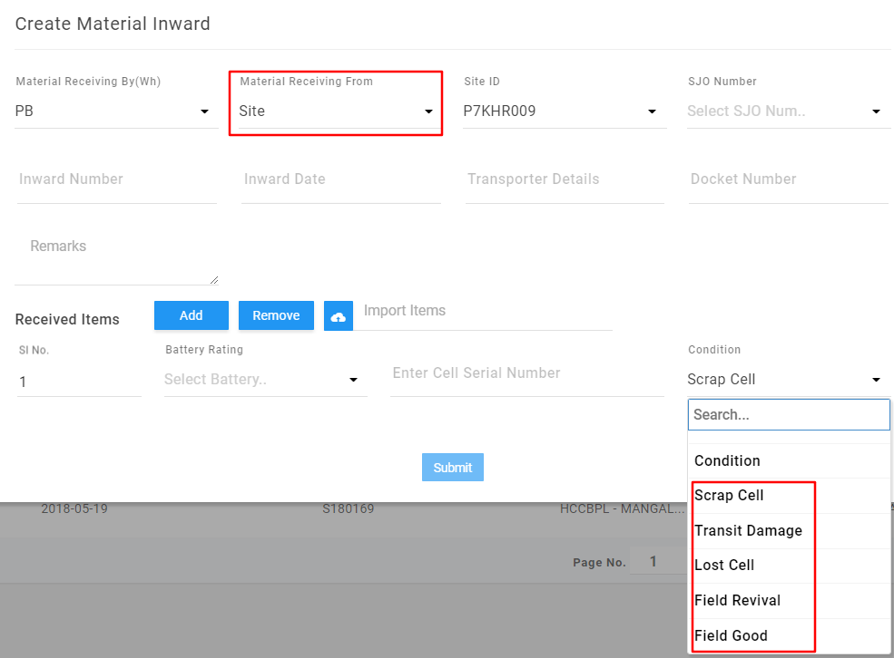

1. Scrap Cell : Cells inward with this condition can be outward to factory.
2. Transit Damage: : Damages cells inward back to warehouse from Site will be considered as Scrap cell in System can be outward to factory.
3. Lost Cell : Faulty cells lost at site will be considered as Dispute in System.
4. Filed Revival : Faulty cell inward with this condition will be routed to Revival module.
5. Filed Good : Cells inward with this condition will be considered as revived condition and can be outward to TT Number.

Key Points:

1. When we select the *Site* in the drop down, next to that the list of site ID mapped to circle will be fetched as shown in the below image.

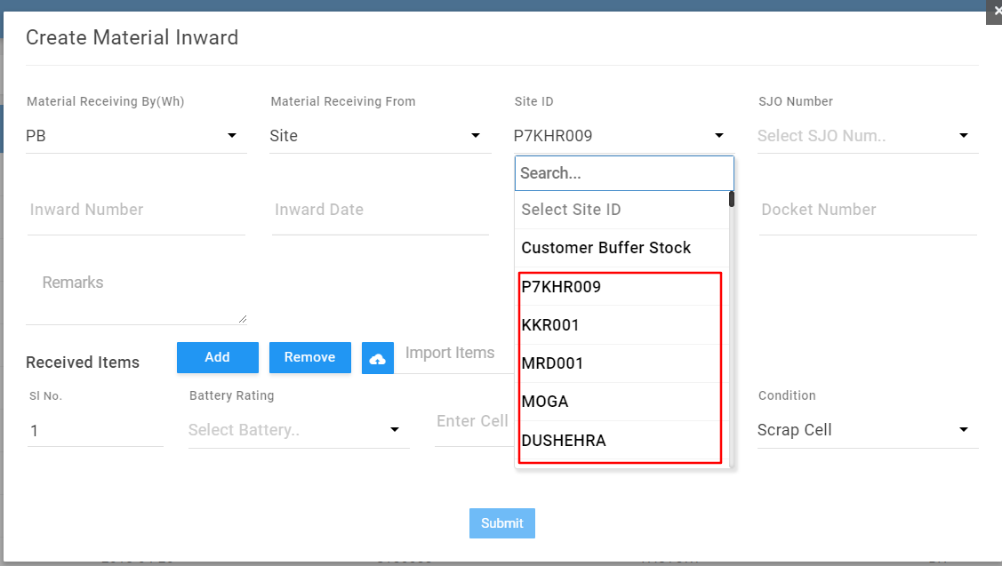

1. The line items are dynamic to inward the cells by selecting *Site.*

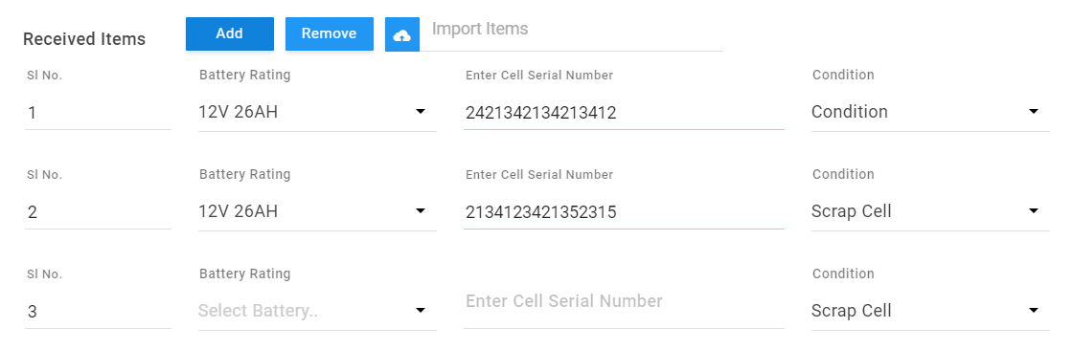

1. **Ticket**: As shown for the case *Site* above here also 5 different cell conditions can be inward at warehouse with mapping of SJO / without mapping of SJO (NON SJO) but, SJO Number in form will be display for selection mapping below criteria.
2. If the TT Number is mapped at the time of material request then SJO number selection will not be shown in the material inward form.

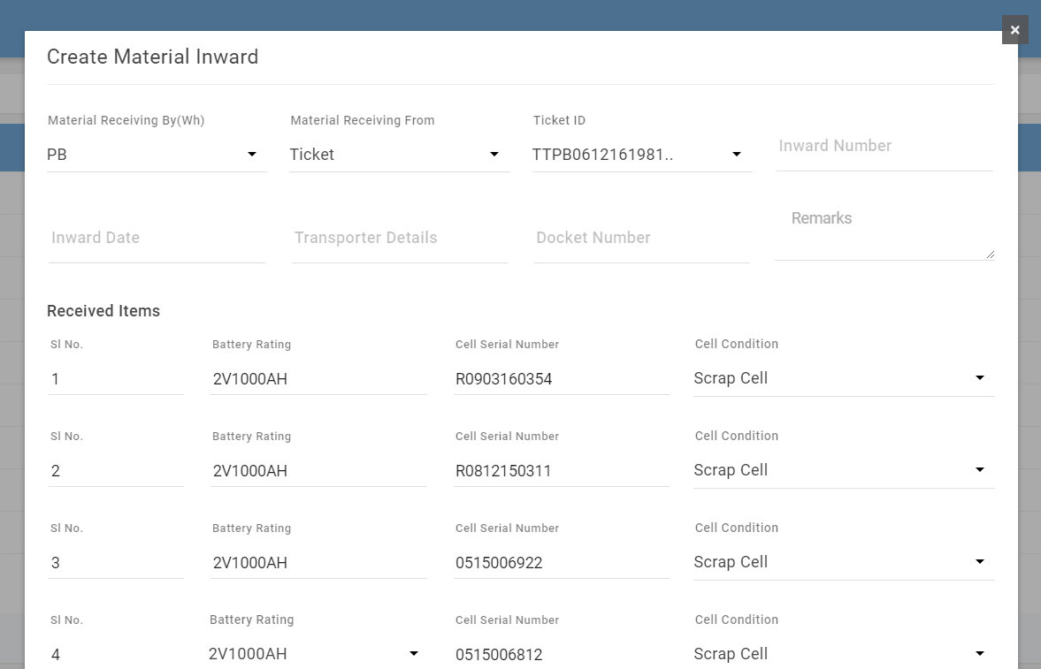

1. If the TT Number is not mapped at the time of material request then the SJO selection in the form is allowed.

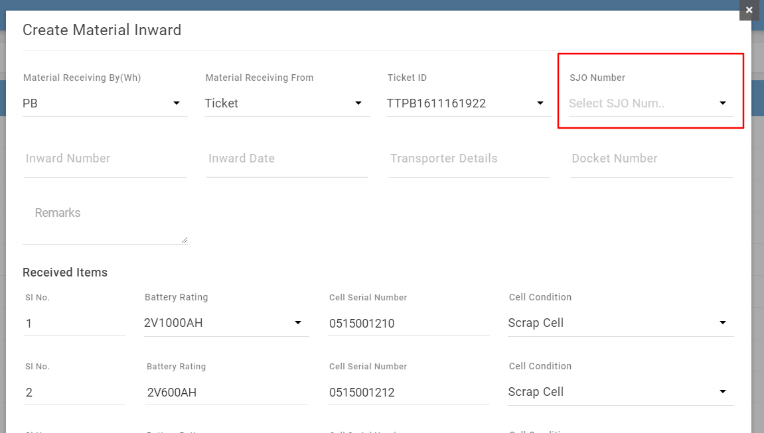

If the cells are mapped with SJO and closed inward transaction then if we select the SJO Number in Material Outward module the same cells which was inward will reflect. The same case with NON SJO also.

* **Material Inward at Factory Side:**

Description: The scrap cells which are outward to factory will be Inward at Factory through web portal. Here the inward will be happened based on the selection of warehouse.

Example 100 cells material outward was done to factory of 5 SJO’s but for inward at factory they will select the ware house not the SJO and the list of cells will be shown for closing transaction.

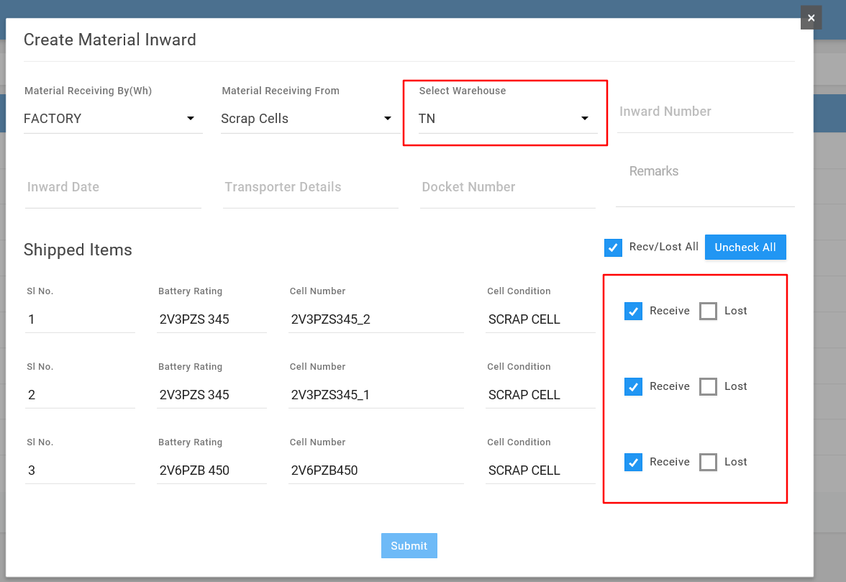

Key Points:

1. At the time of Scrap Inward at Factory against each cell there will a condition to select “Receive” or “Lost”, if selected “Receive” the outstanding against SJO will be reduced, if selected “Lost” the outstanding against SJO will be reduced but the lost count will be under bucket Lost / Dispute.

### 5.8.5 Material Outward

* **Material Outward at Filed Side:**

Description: To create a new transaction, click on bottom right Float button, which will populate a form by filling all the details and submitting reference number will be generated. This page allows to create new material outward transactions in below 3 cases.



1. **Site**: First select the Warehouse against which the material outward need to be created, which will show available stock in warehouse in the form as shown in below image.

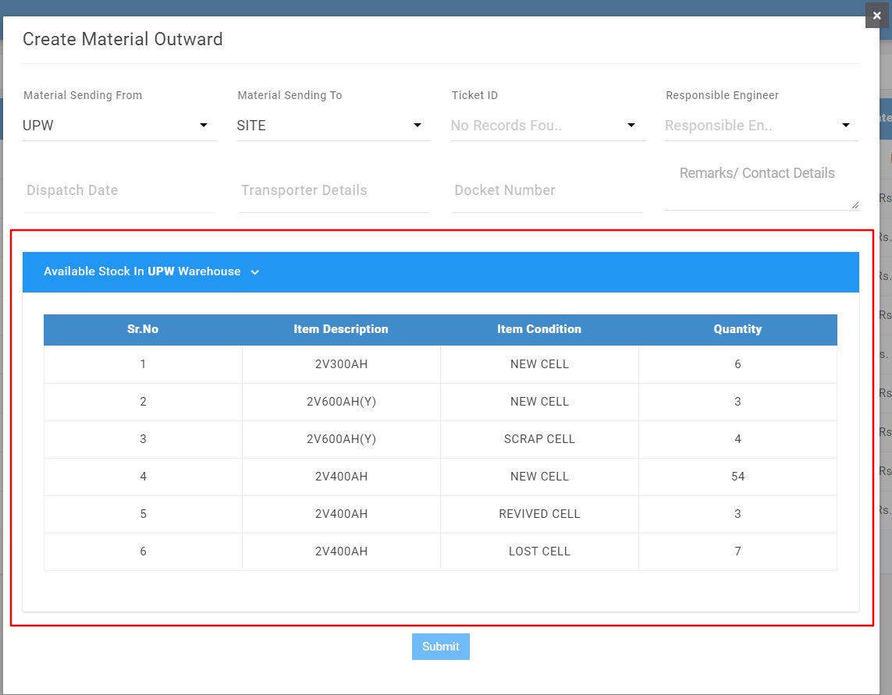

Then select “*Site*” from drop down menu list, by which TT Numbers (which are approved by Technical Service (TS) privilege i.e., TT visit with status “REPL DUE”) will be reflecting in next Drop down, select TT Number, fill rest of the form details and select the cell serial number which are planned to send out to TT Number and click on submit button. Once transaction is generated now the outward cell serial number (against the TT Number) will be reflecting in e-FSR form under *“Service engineer observation” at “Replaced cells”.*

Key Points:

1. The status of the transaction created in web application will be as “Under Transit” once the cell serial selection completed in e-FSR and submitted then status will be changed to “Closed”.
2. If 10 cells made outward to TT but only 5 cells are selected in e-FSR then the rest 5 cell serial numbers will be reversed back to ware house and will be available to outward again.
3. SJO Number display in form will act same as mentioned for Material Inward as specified above.
4. **Factory (Scrap Cells)**: This is about the sending scrap cells to Factory which are inward against SJO Number / NON SJO.

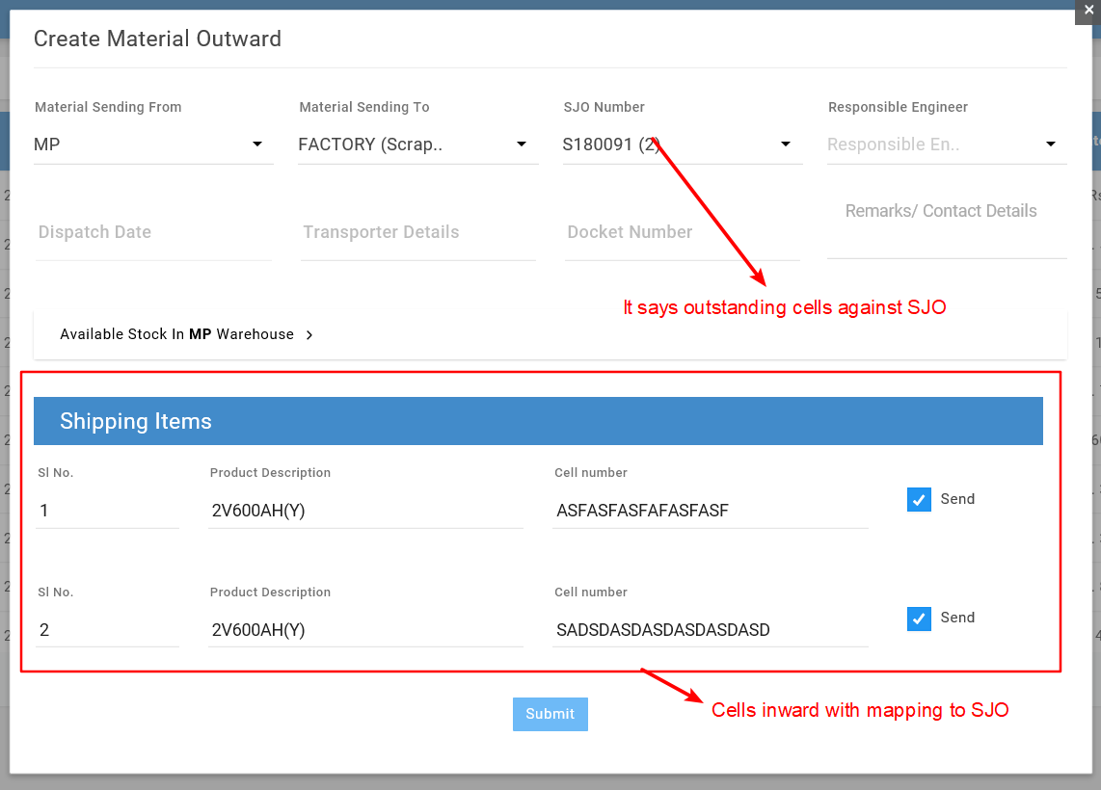

Key Points:

1. The Scrap cells inward against SJO number (with selection of *Site* or *TT Number*) will be reflecting when we select the SJO number in Material Outward.
2. The status of the transaction created in web application will be as “Under Transit” once the Transaction cells inward at Factory declaring they “Receive” then status will be changed to “Closed” if transaction material not completed inward at factory then the status will be “Partially Closed”.

* **Material Outward at Factory Side:**

Description: To create a new transaction, click on bottom right Float button, which will populate a form by filling all the details and submitting reference number will be generated.



This page allows to create new material outward transactions of new cells to field against SJO number from factory.

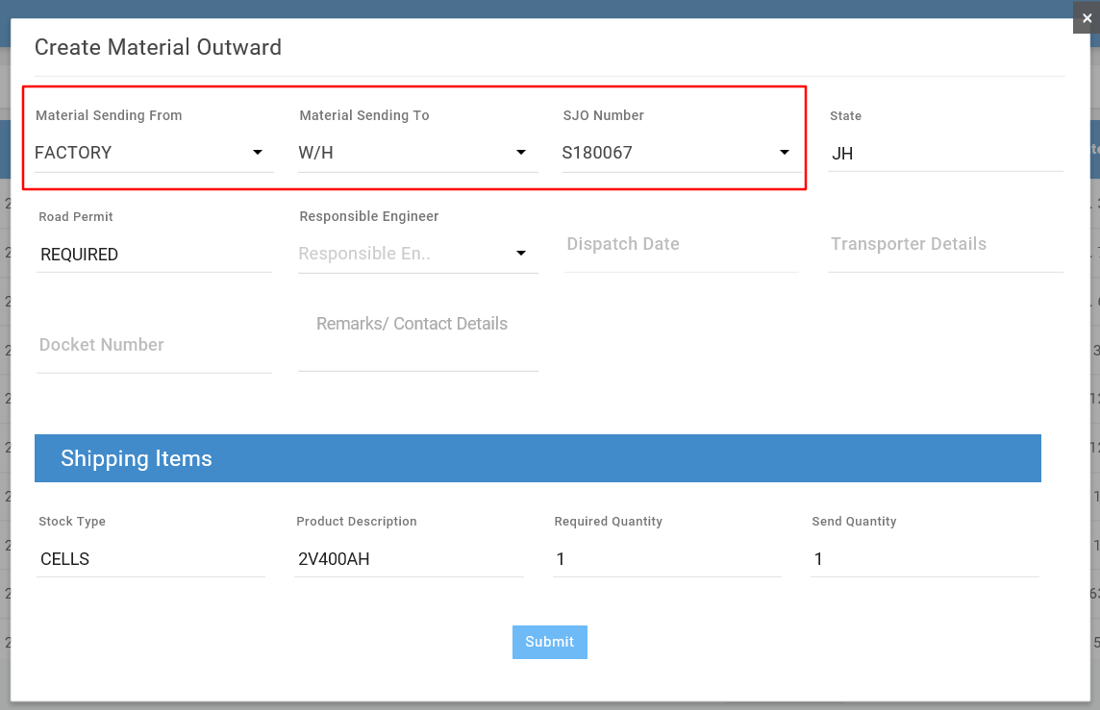

Key Points:

1. The status of the transaction created in web application will be as “Under Transit” once the Transaction cells inward at filed declaring they “Receive” then status will be changed to “Closed” if transaction material not completed inward at factory then the status will be “Partially Closed”.

### 5.8.6 Material Request

* **Material Request to Factory by HO Coordinator:**

Description: To create a new transaction, click on bottom right Float button, which will populate a form by filling all the details and submitting reference number will be generated.



This page allows to create material request of new cells to factory against SJO number by warehouse. The created request travels all the approval levels before reflecting on “*PPC login”*, refer to point number *3-Detailed Flow diagram of EnerSys Care Web Portal* for approval levels after the material request transaction is created.

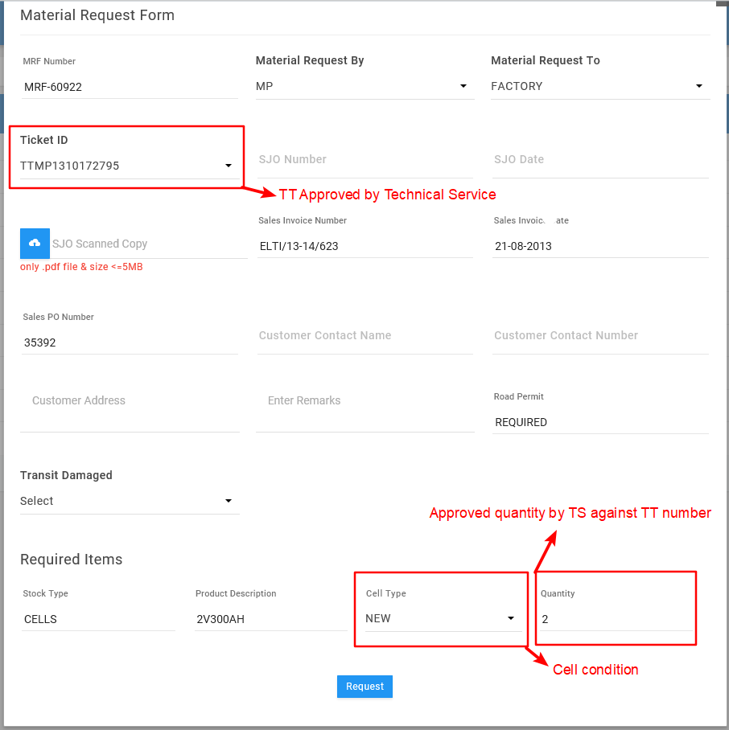

Key Points:

1. Material request can be placed only to factory in 2 scenarios, one is against *TT Number* (which is approved by technical service) and the second is against *Customer Buffer Stock.*

In Scenario-1 the material items can be added manually

In Scenario-2 the material items will be reflecting of TS approved (Only condition can be selected).

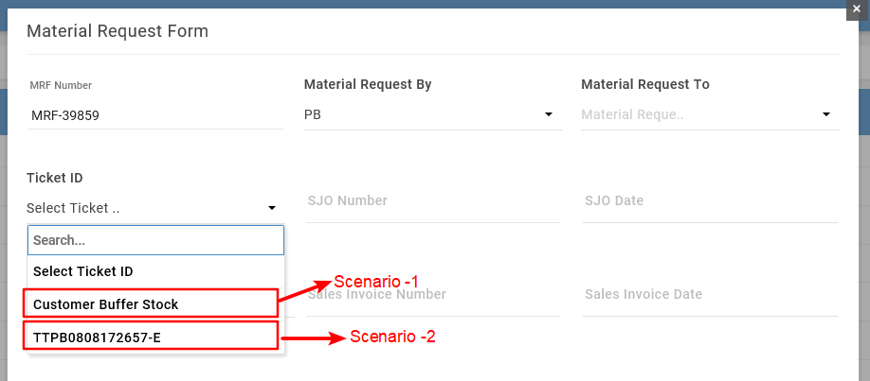

1. Material request can be happened only with same Material Condition Example: Multiple items with *New* / *Revived* any one Condition is allowed, but multiple items with mixed cell conditions is not allowed. This is because the approval routing is different for Cell condition as shown *3-Detailed Flow diagram of EnerSys Care Web Portal.*

* **Material Clearance at Factory by PPC:**

Description: To *update* a transaction, search for SJO Number with status *PPC Pending* edit the transaction and provide the *Material clearance date* & *Quantity* to initiate further process as shown in *3-Detailed Flow diagram of EnerSys Care Web Portal. (Step referring- PPC).*

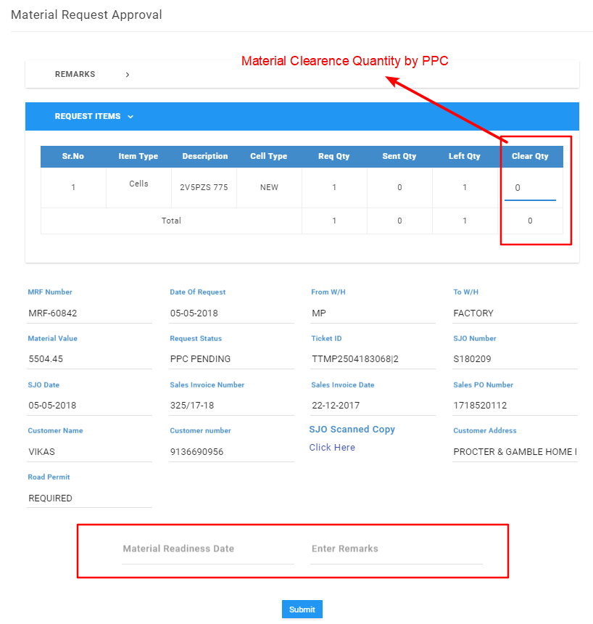

Key Points:

1. Material clearance quantity can be done partially also, Example if the material request is for 100 cells PCC can clear 50 cells and submit the transaction, now the status of SJO will be *Partially Closed.*
2. PPC cannot clear the balance 50 cells to the same SJO until the first cleared cells Inward at filed.

* **Material Request Levels:**

Description: The following are the different levels against the material request:

1. Dynamic Pending : Material requested waiting for Dynamic Approvals.
2. Dynamic Hold : SJO Kept under Hold
3. Dynamic Rejected : SJO rejected by Dynamic Approvals, now the transaction will go back to Requestor to modify the details and resubmit again.

1. PPC Pending : Got cleared Dynamic Approvals and SJO waiting for PPC input / Material clearance.
2. Packing Pending : SJO Cleared by PPC and waiting for quality department to upload cell serials against the material requested quantity.
3. Invoice Pending : Cells serial number uploaded by quality team and now SJO waiting for Commercial Dept. to add Invoice details.
4. Dispatch Pending : SJO has now Invoice details and waiting for Logistic team to add dispatch details.
5. Under Transit : SJO now dispatched from factory and pending to receive at field.
6. Short Closed : Material requested initiated and got short closed by NHS (this can be happened only if the material request is lying at PPC level)
7. Closed : Material sent from factory got inward by Field.
8. Partially Closed : Material requested quantity is not completely shipped from factory and balance to be dispatched. For this PPC need to act provide clearance date again to initiate the process

### 5.8.7 Revival

Description: To create a new transaction, click on bottom right Float button, which will populate a warehouse selection form by selecting the warehouse revived cells available in warehouse will be reflecting.



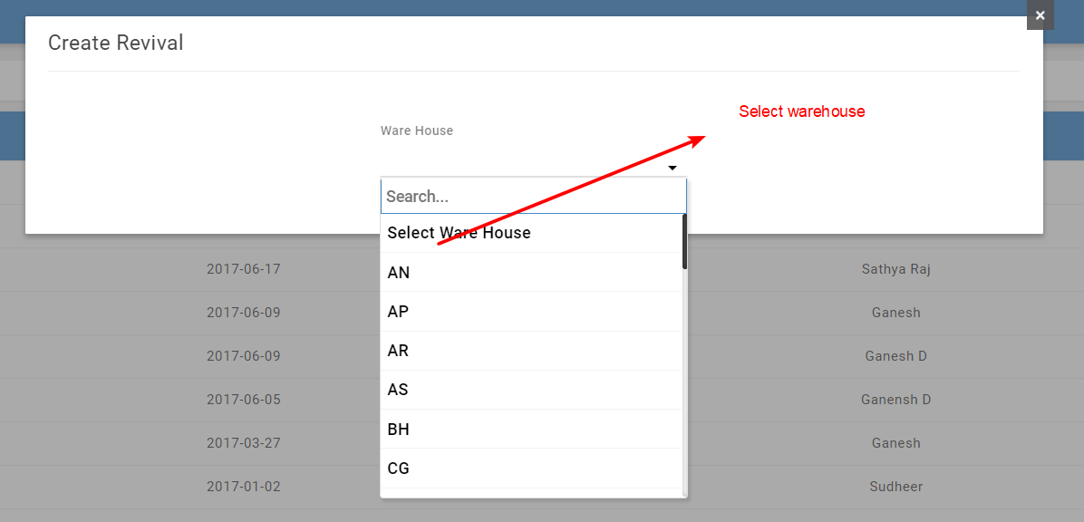

The cells which are inward from site as a condition as *Filed revival* will reflect here, now each cell can be declared a result condition as following

1. **Pass:** If the revival result is declared as *Pass* then the cell condition will become *Revived* and can be outwarded to any TT Numbers.
2. **Fail:** If the revival result is declared as *Fail* then the cell condition will become *Scrap* and can be outwarded to Factory.

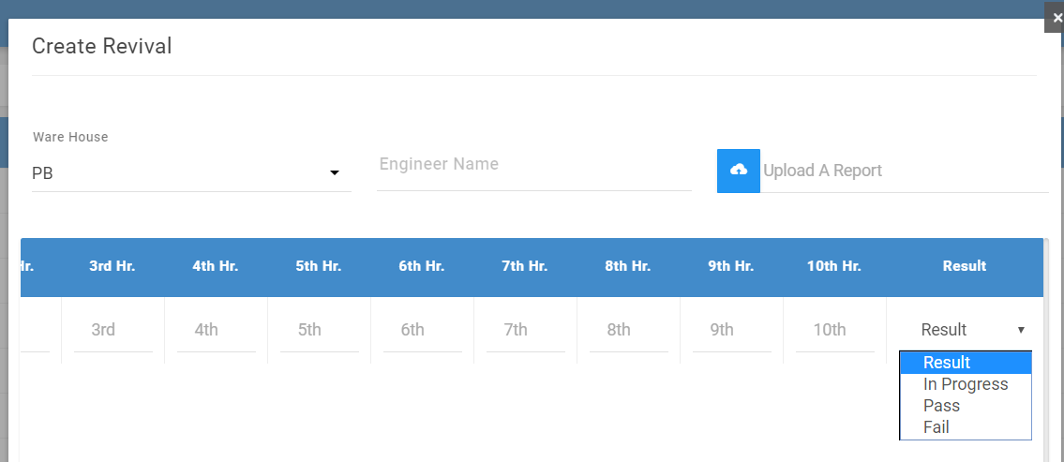

Key Points:

1. Example if we selected a warehouse and there are around 100 cells pending for revival it is not mandatory that we should make a single transaction, instead we can do multiple transactions.

### 5.8.8 Refreshing

Description: To create a new transaction, click on bottom right Float button, which will populate a warehouse selection form by selecting the warehouse pending for Refreshing cells available in warehouse will be reflecting.



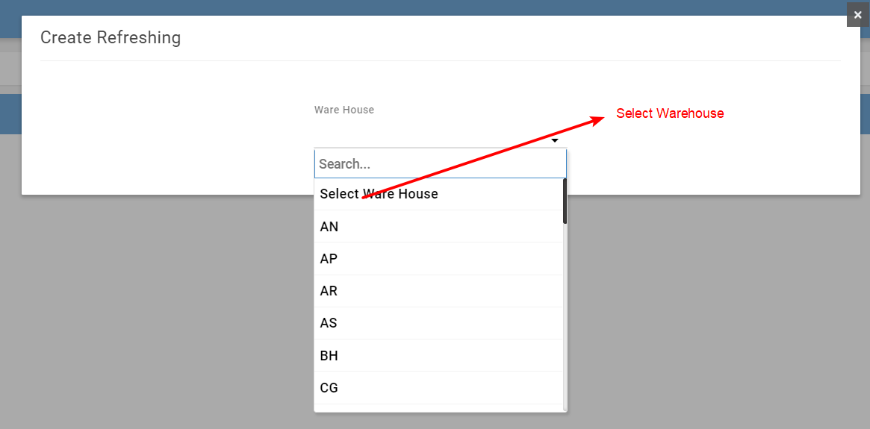

if a cell lying at warehouse with condition *New or Revival* more than 60 days then the cell serial numbers will be reflecting under Refreshing module, now each cell can be declared a result condition as *Charged* as shown in the below image.

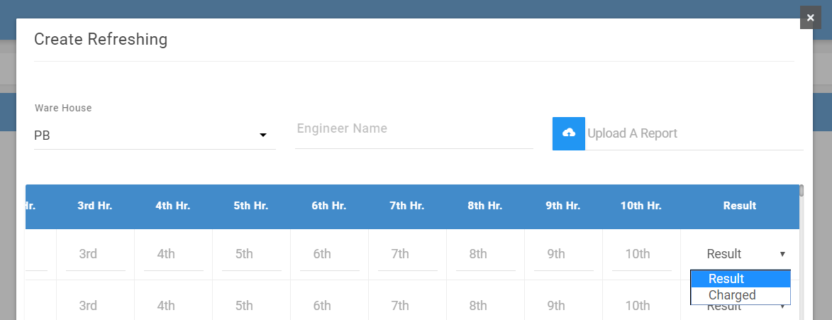

Key Points:

1. Example if we selected a warehouse and there are around 100 cells pending for Refreshing it is not mandatory that we should make a single transaction, instead we can do multiple transactions.

### 5.8.9 Stocks

* **Stock Add at Factory QC Dept.**

Description: To *add* a stock, click on bottom right Float button, which will populate a SJO Number selection form by selecting the SJO number material requested cells rows will be reflecting to upload the cell serial numbers against the SJO Number.

Post adding the cell serial numbers and submitting the form, transaction will route to further processing as shown in *3-Detailed Flow diagram of EnerSys Care Web Portal. (Step referring – QC Dept. will upload cell serial numbers)*



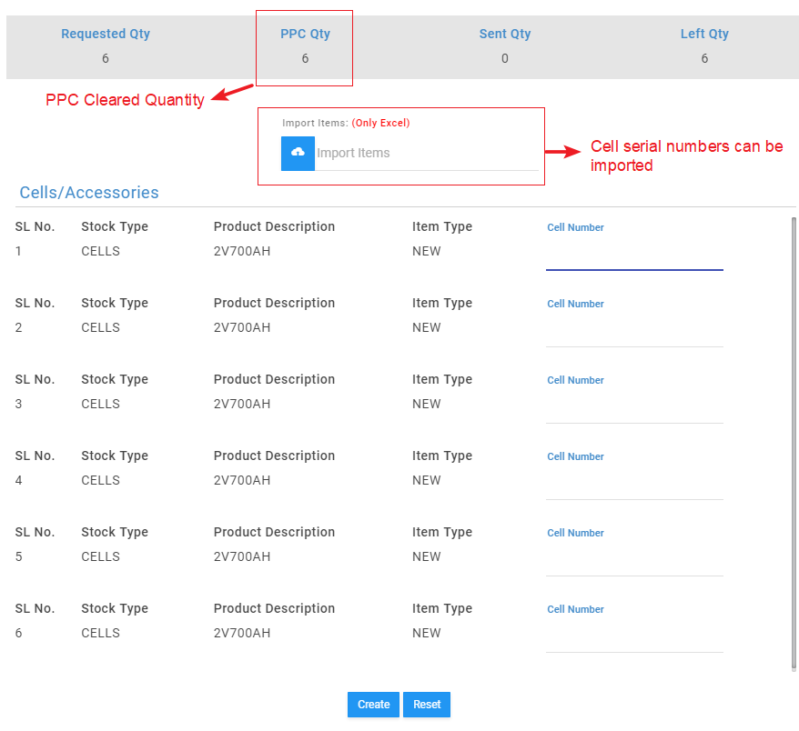

* **Stock update at Factory Commercial Dept.:**

Description: To *add* commercial data, click on bottom right Float button, which will populate a SJO Number selection form by selecting the SJO cells mapped against the SJO Number will be showing and will ask to input *Invoice Details* and will route to further processing as shown in *3-Detailed Flow diagram of EnerSys Care Web Portal. (Step referring – Commercial Dept. enters Invoice details).*

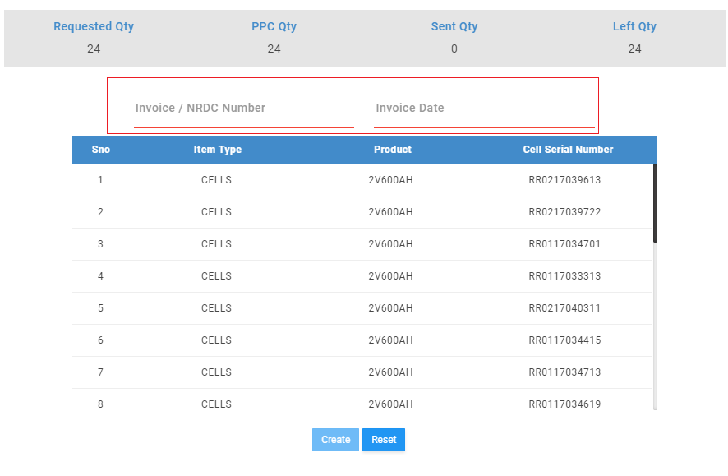

* **Stock at Filed:**

Description: The material inward transactions to *Warehouse* from *Site* with following cell conditions will create a new stock.

1. Scrap
2. Filed Revival
3. Field Good cells

Key Points:

1. The stock created will track the history of each cell serial number as shown below.

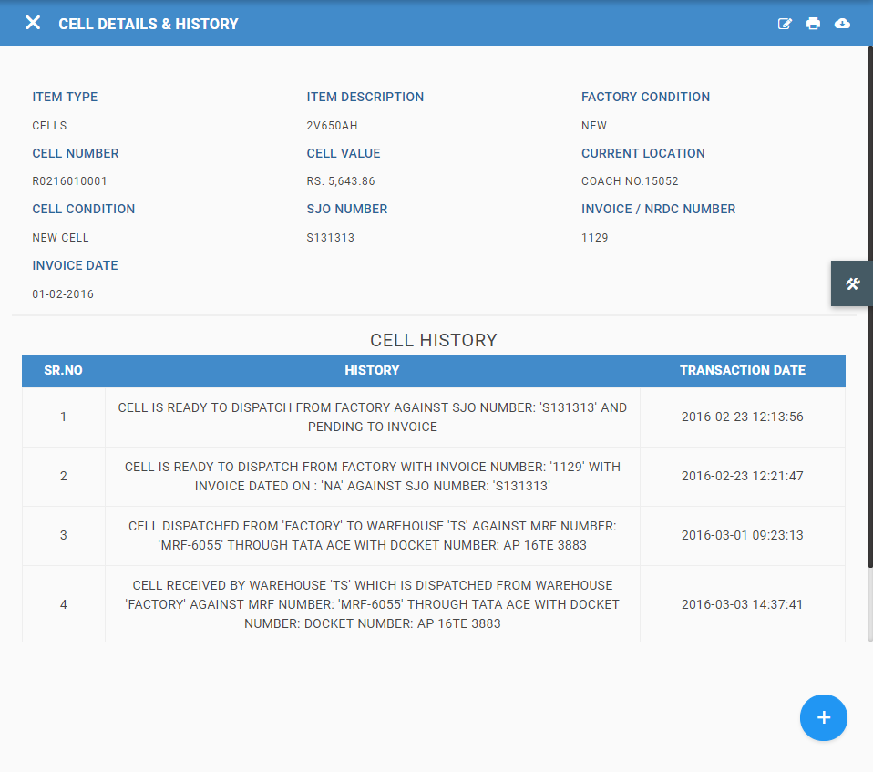

1. Duplicate Stock creation is not allowed by the system, Example: Each cell serial number should be unique.

### 5.8.10 SJO Search

Description: This module provides us Cell serial number mapping / Movement against SJO Number. (Inward and Outward Transaction Made by Selecting SJO Number). To get the Results, input the SJO number in search box and press Search button.

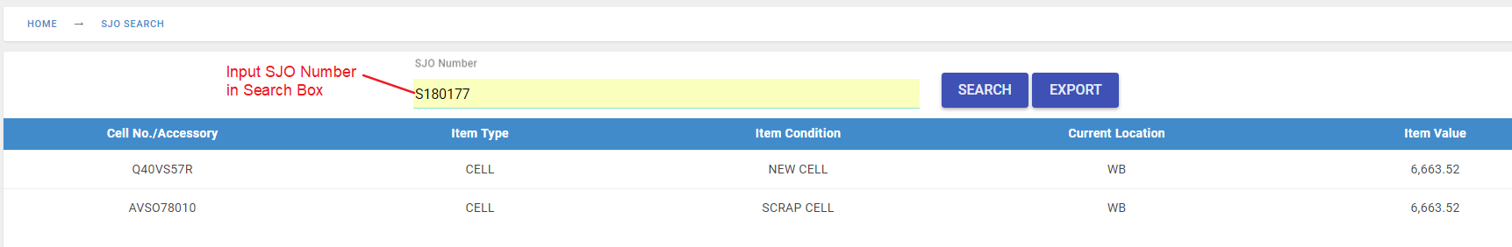

### 5.8.11 Export

List of reports that are available in the Filed Asset Management:

|  |  |  |
| --- | --- | --- |
| **Module** | **Description** | **Remarks** |
| SJO Balance | Financial Export | Can export Archive data of Previous Financial Years |
| Balance Sheet Export | Overall Table view can be exported |
| SJO Tracking Export | Captures SJO wise outstanding Balance |
| Inward Balance | Export | Overall Table view can be exported |
| Outward Balance | Export | Overall Table view can be exported |
| Material Inward | Export | Inward transaction details |
| Material Outward | Export | Outward transaction details |
| Material Request | Export | Material requested transaction details |
| Revival | Export | Revival transaction details |
| Refreshing | Export | Refreshing transaction details |
| Stocks | Export | History and Condition of cell details |
| SJO Search | Export | Resulted Table view can be exported |

## 5.9 User Tracking

Description: User Tracking Module is introduced to track the activities of Web users and Location tracking of Mobile application users.

*Web users Activity:*

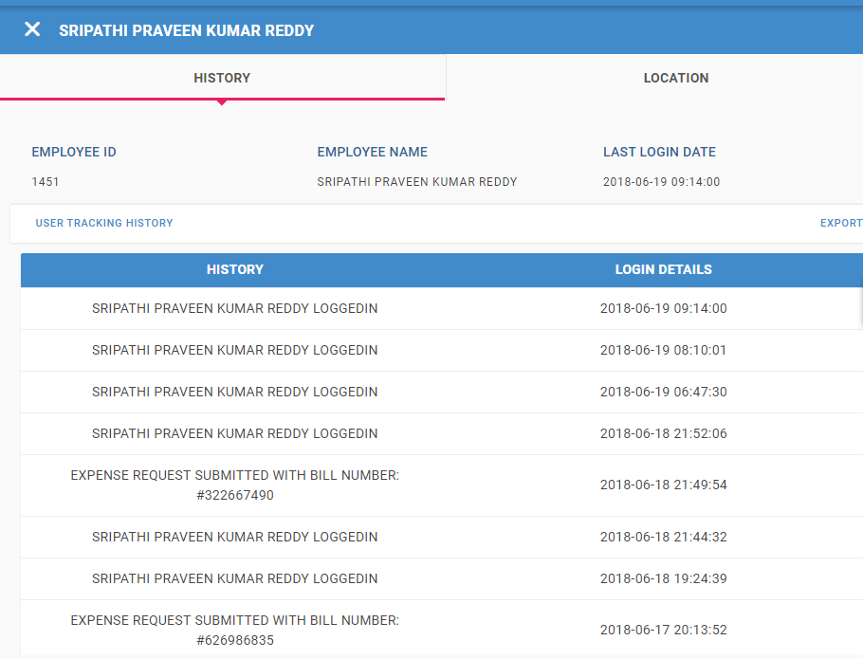

*Mobile application users Activity:*

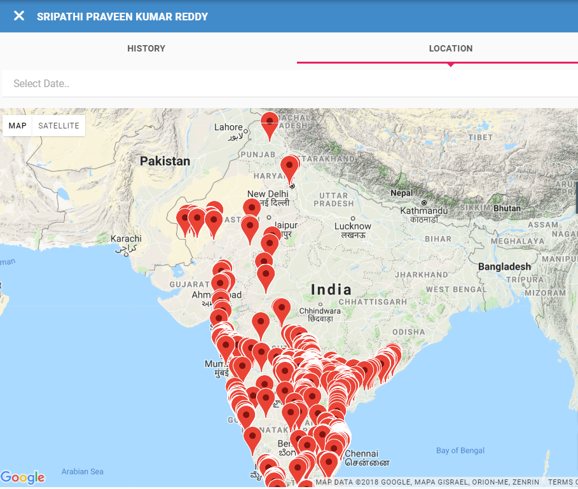

### 5.9.1 Export

List of reports that are available in the User Tracking:

1. Detail Last login details of web application of all the web users
2. Activity details export for web users.

## 5.10 IMEI Control

Description: IMEI Control Module is introduced to Activate / Deactivate the permissions to use *System Safe* Android mobile application.

### 5.10.1 Activate Device

Description: To Activate device, click on *Activate* button which will pop up the form to input Device IMEI Number. Click on update button once the IMEI numbers are entered.





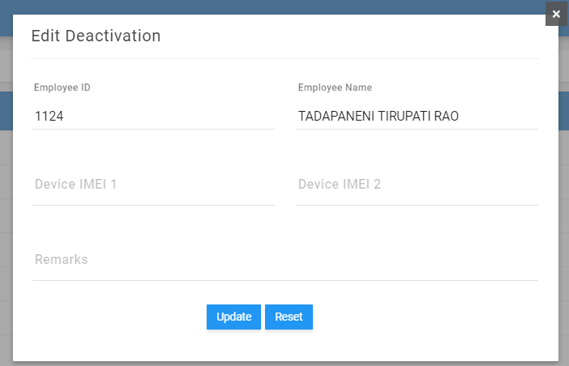

### 5.10.2 Deactivate Device

Description: To Deactivate device, click on *Deactivate* button which will pop up the form to reconfirm. Click on Deactivate button in the popup.



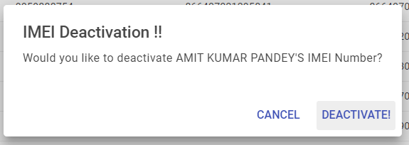

### 5.10.3 Export

List of reports that are available in the User Tracking:

1. Detail Active and Deactivate users list with Remarks